

KARASUPORT FACILITY
DANGEROUS GOODS GUIDE

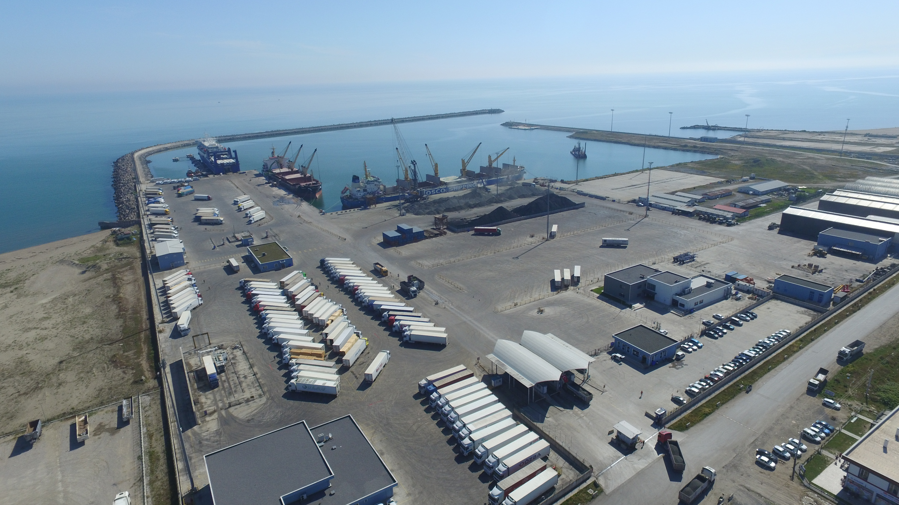

ISSUE DATE: 17 DECEMBER 2016
(See the revisions in Revision Page)

GÖKÇEN ERDEM

REVISION PAGE
Revision No | Revision content | Revision Date | Revised by
Revision No | Revision content | Revision Date | Name Surname | Signature
1 | Elimination of the problems observed in auditing | 16.02.2017 | Fatih KÖSE
2 | Facility İnformation  Form | 30.07.2017 | Fatih KÖSE
3 | Facility İnformation  Form | 20.11.2018 | Fatih KÖSE
4 | Facility İnformation  Form | 25.05.2022 | FATİH KÖSE
5 | Dangerous Goods Guide Application Instruction | 16.06.2022 | MEHMET ŞILAK
6 | Dangerous Cargo Relevance Certificate Auditing | 25.11.2022 | MEHMET ŞILAK
7 | Permit for Explosive Dangerous Goods | 08.11.2023 | Hakan YEŞİL
8 | Coordinates | 31.10.2025 | Hakan Yeşil

CONTENTS

REVİSİON PAGE Hata! Yer işareti tanımlanmamış.
CONTENTS Hata! Yer işareti tanımlanmamış.
1. INTRODUCTION Hata! Yer işareti tanımlanmamış.
1.1 General information of facility: Hata! Yer işareti tanımlanmamış.
1.2 Loading/discharge, handling and storage procedures of dangerous goods handled and temporarily stored in shore facility: Hata! Yer işareti tanımlanmamış.
2. RESPONSIBILITIES: Hata! Yer işareti tanımlanmamış.
2.1 Responsibilities of those responsible for the goods: Hata! Yer işareti tanımlanmamış.
2.2 Responsibilities of shore facility operator Hata! Yer işareti tanımlanmamış.
2.3 Responsibilities of the Ship Captain: Hata! Yer işareti tanımlanmamış.
2.4 Responsibilities of Dangerous Goods Safety Advisor:: Hata! Yer işareti tanımlanmamış.
2.5 Responsibilities of third party, cargo/ship agency engaged in shore facility: Hata! Yer işareti tanımlanmamış.
2.6 Responsibilities of Ship Person………………………………..………………………………………………19
2.7 Carrier's Responsibilities of Carrier's……………………………………………………………………….19
3. RULES TO BE FOLLOWED/APPLIED AND MEASURES TO BE TAKEN BY SHOR Hata! Yer işareti tanımlanmamış.
3.1 Rules to be followed by Shore facility Operators: Hata! Yer işareti tanımlanmamış.
3.2 Measures to be taken by Shore facility Operators: Hata! Yer işareti tanımlanmamış.
3.3 Facility Loading Safety Rules Hata! Yer işareti tanımlanmamış.
3.4 Rules Regarding Dangerous Goods within the Scope of IMSBC Code: 35
3.5 Rules Regarding Dangerous Goods within the Scope of IMDG Code:: 36

4. CLASSES, TRANSPORTATION, LOADING/DISCHARGE, HANDLING, SEGREGATION, STOWING AND STORAGE OF DANGEROUS GOODS: Hata! Yer işareti tanımlanmamış.
4.1 Classes of Dangerous Goods: 37
4.2 Packs and packagings of dangerous goods: Hata! Yer işareti tanımlanmamış.
4.3 Placards, plates, brands and labels related to the Dangerous goods handled in our shore facility are as follows: 38
4.4 Marks and packaging groups of dangerous goods: 42
4.5 Ship and Port Breaking Tables According to Classes of Hazardous Materials: Hata! Yer işareti tanımlanmamış.
4.6 Dangerous Goods Documents: Hata! Yer işareti tanımlanmamış.
5. MANUAL FOR DANGEROUS CARGOES HANDLED IN SHORE FACILITY Hata! Yer işareti tanımlanmamış.
6. OPERATIONAL ISSUES Hata! Yer işareti tanımlanmamış.
6.1 Procedures for safely berthing, mooring, loading/discharging, harbouring or anchoring of ships transporting dangerous goods at night and day: Hata! Yer işareti tanımlanmamış.
6.2 Procedures for additional measures taken for loading, discharging and transshipment according to seasonal conditions: Hata! Yer işareti tanımlanmamış.
6.3 Procedures for keeping away flammable, combustible and explosive materials from spark-producing operations and not operating vehicles, equipment and tools capable of sparking in fields of dangerous goods handling, stowing and storage: Hata! Yer işareti tanımlanmamış.

7. DOCUMENTATION, CONTROL AND RECORD : Hata! Yer işareti tanımlanmamış.
7.1 Relevant Required Document Hazardous Substances Information and documents what it is, these procedures are by-Related Supply and Control: Hata! Yer işareti tanımlanmamış.
7.2 Coastal resort course in all regular and complete Keeping Procedures As of the current List of Hazardous Substances and Other Related Information: 49
7.3 Procedures for control of properly defining of dangerous goods in the facility, using proper shipping names,certificating, packaging/packed, labeling and declaring of dangerous goods, loading to approved package, container or good cargo transport unit in accordance with rules and transporting in a safe condition and reporting the results of control: Hata! Yer işareti tanımlanmamış.
7.4 Procedures for obtaining and keeping dangerous goods safety information form (SDS):…. Hata! Yer işareti tanımlanmamış.
7.5 Procedures for keeping records and statistics of dangerous goods.: Hata! Yer işareti tanımlanmamış.
7.6 Information on Quality Management System: Hata! Yer işareti tanımlanmamış.

8. EMERGENCIES, PREPAREDNESS FOR EMERGENCIES AND RESPONSE: Hata! Yer işareti tanımlanmamış.
8.1 Response procedures for dangerous goods that endangers/able to endanger life, property and/or environment and dangerous incidents involving dangerous goods: Hata! Yer işareti tanımlanmamış.
8.2 Information for possiblity, capacity and capability of shore facility to response emergencies: Hata! Yer işareti tanımlanmamış.
8.3 Regulations of first Response for accidents involving dangerous goods: Hata! Yer işareti tanımlanmamış.
8.4 Notifications to be made in and out of the premises in emergency situations:. Hata! Yer işareti tanımlanmamış.
8.5 Accident Reporting Procedures.: Hata! Yer işareti tanımlanmamış.
8.6 Coordination, support and cooperation method with official authorities. 62
8.7 Emergency evacuation plan for removal of ships and marine vessels from coastal installations in an emergency. 62
8.8 Procedures for handling and disposal of damaged hazardous cargoes and hazardous cargoes Hata! Yer işareti tanımlanmamış.
8.9 Emergency drills and their records. Hata! Yer işareti tanımlanmamış.
8.10 Information on Fire Protection Systems 63
8.11 Procedures for Approval, Inspection, Testing, Maintenance and Use of Fire Protection Systems Hata! Yer işareti tanımlanmamış.
8.12 Precautions to be Taken When Fire Protection Systems Do Not Work 66
8.13 Other Risk Control Equipment Hata! Yer işareti tanımlanmamış.
9. OCCUPATIONAL HEALTH AND SAFETY: Hata! Yer işareti tanımlanmamış.
9.1 Occupational Health and Safety Precautions Hata! Yer işareti tanımlanmamış.
9.2 Information on personal protective clothing and procedures for their use Hata! Yer işareti tanımlanmamış.
9.3 Closed Space Entry Permit Measures and procedures Hata! Yer işareti tanımlanmamış.

10. OTHER ISSUES 68
10.1 Validity of Dangerous Goods compliance Certifica Hata! Yer işareti tanımlanmamış.
10.2 Dangerous Goods Security Advisor Task Description Hata! Yer işareti tanımlanmamış.
10.3 Issues for carrier of dangerous goods to the shore facility /from the shore facility by land (documents to be kept by road vehicles during entrance/exit of port or shore facility field, equipment and tools kept by these vehicles; port field speed limits, etc) Hata! Yer işareti tanımlanmamış.
10.4 Issues regarding to the carriers of dangerous goods to coming the shore facility/leaving from shore facility by sea (exhibition of signals by ships and sea vehicles to the port or shore facility by day/at night, cold and hot working procedures aboard ship) Hata! Yer işareti tanımlanmamış.
10.5 Additional issues added by shore facility Hata! Yer işareti tanımlanmamış.
11. ANNEXES… Hata! Yer işareti tanımlanmamış.
EK-1 General Layout of Shore facility Hata! Yer işareti tanımlanmamış.
EK-2 Photo of General Appearance of Shore facility Hata! Yer işareti tanımlanmamış.
EK-3 Emergency Contacts and Contact Information 77
EK-4 General Layout Plan of Fields that Dangerous Goods Handled Hata! Yer işareti tanımlanmamış.
EK-5 Fire Plan of Field that Dangerous Goods Handled Hata! Yer işareti tanımlanmamış.
EK-6 General Fire Plan of Facility Hata! Yer işareti tanımlanmamış.
EK-7 Emergency Action Plan Hata! Yer işareti tanımlanmamış.
EK-8 Emergency Meeting Point Plan Hata! Yer işareti tanımlanmamış.
EK-9 Emergency Management Plan Hata! Yer işareti tanımlanmamış.
EK-10 Dangerous Goods Manual Hata! Yer işareti tanımlanmamış.
EK-11 Leakage Areas, Equipment, Entrance/Exit Drawings for CTU and Packages. Hata! Yer işareti tanımlanmamış.
EK-12 Inventory of Port Service Ships Hata! Yer işareti tanımlanmamış.
EK-13 Port Authority Administrative Boundaries, Anchoring Locations and Harbor Pilot Marine coordinates of Landing/boarding points Hata! Yer işareti tanımlanmamış.
EK-14 Emergency Response Equipment against Marine Pollution in Port facility Hata! Yer işareti tanımlanmamış.
EK-15 Personal Protective Equipment (PPE) Use Map Hata! Yer işareti tanımlanmamış.
EK-16 Notification Form for Dangerous Goods Incident Hata! Yer işareti tanımlanmamış.
EK-17 Notification Form for Control Results of Dangerous Goods Cargo Transport Units (CTUS)………….. Hata! Yer işareti tanımlanmamış.
EK-18 Multimodal Dangerous Goods Form Hata! Yer işareti tanımlanmamış.
EK-19 Dangerous Load Handling Guide Additional Load Notice………………………………………..77

12. ABBREVIATIONS Hata! Yer işareti tanımlanmamış.
13. DEFINITIONS Hata! Yer işareti tanımlanmamış.
14. PRESENTMENT Hata! Yer işareti tanımlanmamış.

INTRODUCTION:

When the dangerous goods are handled or stored in entrance of port and port areas, general safety and security must be provided, the goods must be surrounded, all safety measures must be taken for all people in or near port area and the environment must be protected, all these must be controlled.

General information of facility :

FACILITY INFORMATION FORM
1 | Name/title of facility operator | IC İÇTAŞ SAKARYA KARASU LİMANI YATIRIM VE İŞLETME A.Ş
2 | Contact Information of facility operator (address, phone, fax, e-mail and web page) | Yalı Mah. Batı Karadeniz Cad. No:244 54500 Karasu Sakarya-TÜRKİYE
3 | Name of facility | KARASU PORT
4 | Province of the facility | SAKARYA
5 | Contact Information of facility (address, phone, fax, e-mail and web page) | Yalı Mah. Batı Karadeniz Cad. No:244 54500 Karasu Sakarya-TÜRKİYE
6 | Geographical area of facility | MARMARA region
7 | Port Authority of facility and contact details | KARASU harbour master  Tel: 0(264) 718 12 30 Fax: 0(264) 718 12 29
8 | The municipality where the facility is connected and contact details | İSTANBUL region management
9 | Name of the Free Zone or Organized Industrial Zone where the plant is located | SAKARYA BÜYÜKŞEHİR municipality
10 | Validity date of shore facility Operating Permit/Provisional Operating Permit | 08/12/2022
11 | Facility operating status (X) | Own and third parties ( X) | own (…) | Third parties  (…)
12 | Name and surname of the facility manager, contact details (phone, fax, e-mail) | GÖKÇEN ERDEM  0530 568 28 27  gökcen.erdem@ictas.com.tr  www.karasuport.com.tr
13 | Name and surname of responsible person for dangerous goods operation of facility, contact information information  (phone, fax, e-mail) | FATİH KÖSE  05384072136  fatih.kose@karasuport.com.tr

14 | Name and surname of Dangerous Goods Safety Advisor of Facility, contact information information(phone, fax, e-mail) | Mehmet ŞILAK: 0545 293 64 71  mehmet.silak@ayemis.com
15 | Marine coordinates of facility | 41°07'17"N-030°40'37"E
16 | Type of dangerous goods handled in facility (goods under MARPOL Annex-1, IMDG Code, IBC Code, IGC Code, IMSBC Code, Grain Code, TDC Code and asphalt/bitumen and scrap goods) | Packaged dengeous good  Solid bulk dangerous goods  Grain Kod  TDC Kod  Explosive Dangerous Goods
17 | Dangerous goods handled at the facility (loads other than the IMDG Code, among the cargo types in Article 16, will be written separately. Additional cargo request will be sent to the port authority with Annex-1 form. It will be added to TYER when appropriate) | Petroleum Coke  Coal  Amorphous (Amorphous) Sodium Silicate Lumps
18 | Classes for cargo handled, subject to IMDG Code | Class 1  Class 2  Class 3  Class 4.1, Class 4.2, Class 4.3,  Class 5.1, Class 5.2,  Class 6.1  Class 8  Class 9
19 | Groups in characteristic table for handled cargo subject to IMSBC Code | Petroleum Coke - Group B  Coal – Group B – ( And A )  Amorphous (Amorphous) Sodium Silicate Lumps – Group B
20 | Types of Ship berthing to facility | GENERAL CARGO,BULK SOLID CARGO, RO-RO(RO-PAX) and CONTAINER
21 | Facility’s distance to main road (kilometer) | 1 Km.
22 | Facility’s distance to railway (km) or railway connection (Yes/No) | 55 Km.
23 | Facility’s distance to closest airport (km) and its name | 98 Km.
24 | Goods handling capacity of facility  (Ton/Year; TEU/Year; Vehicle/Year) | Genel kargo : 5.000.000 Ton/Year  Konteyner : 150.000 TEU/Year  Ro-Ro/Ro-Pax : 110.000 Unit/ Year
25 | Scrap handling made/not made in facility | no
26 | Is there border crossing (Yes/No) | yes
27 | Is there a bonded areas?(Yes/No) | yes
28 | Goods Handling equipment and capacity | - MHC (MOBİL HARBOUR CRANE)
29 | Storage tank capacity (m³)
30 | Open storage area (m²) | 230.000 m²
31 | Semi-closed storage area (m²) | -
32 | Closed storage area (m²) | 6530 M²
33 | Determined fumigation and/or decontamination from fumigation area (m²) | -
34 | Name/title of pilotage and towage service provider, contact information | KARASUPORT PİLOTAGE AND TOWAGE STATİON  PİLOT 1 Haktan Demirboğa 0505 369 87 19  PİLOT 2 Gökhan YILMAZ 0533 354 92 97
32 | Have Security Plan was created?  (Yes No) | Have.

33 | Capacity of Waste Acceptance Facility  (This part will be issued separately according to the waste accepted by facility) |  |  | Waste Type |  | Capacity (m³)
33 |  |  |  | Bilge  Sludge  Waste oil  Dirty Oil  dirty water  Garbage |  | 40  40  50  55  - Municipal sewage discharge  10
34 | RIHTIM/İSKELE VB. ALANLARIN ÖZELLİKLERİ
Berth/Jetty No |  | Height (meter) | Width (meter) | Maximum water depth  (meter) | Min, mum water depth  (meter) |  | Tonnage and height of The largest ship berthed  (DWT or GRT - meter)
Pier No. 1 |  | 244 | 20 |  | 11 |  | 60.000 DWT  (Dependent on Ship Type)
Pier No. 1 |  | 213 | 20 |  | 11 |  | 60.000 DWT  (Dependent on Ship Type)
Dolfen |  | 41° 7'26.26"N  030°40'23.92"E |  |  | 11 |  | 60.000 DWT
The name of the pipeline (in the plant) |  |  |  | Count  (Piece) | Length  (Meter) |  | Diameter of  (İnch)
- |  |  |  | - | - |  | -

Loading/discharge, handling and storage procedures of dangerous goods handled and temporarily stored in shore facilities :

Hazardous Cargoes Handled and Temporarily Stored in our Coastal Facilities are as Below.

Since the main status of our coastal facility is the loading/unloading of third-party cargoes, the type of future dangerous goods is not certain. However, when any dangerous goods are started to be handled, they will be imported into this guide.

At this stage, only general principles have been determined for bulk cargoes, and the principles of packaged cargoes, dangerous goods within the scope of IMSBC code and grain cargoes carried in containers/ro-ro are specified.

In case of handling of cargo within the scope of TDC code, international and national
requirements will be met.

Accrual / Discharge Procedure for Hazardous Loads Handled and Temporarily Stored (Except for Packed Loads) :

Acceptance Procedure:

Container carrying dangerous goods subject to customs regime has been declared to the Customs Administration and according to the Customs Administration declaration;

•RED for physical examination and document control;
•SARI for checking the accuracy of the declaration and its annexes without the need for physical examination;
•BLUE, where declarations and documents will be checked later,
GREEN where document control and goods are not physically inspected;
it determines FULL DETECTION, PARTIAL INSPECTION, EXTERNAL INSPECTION by making a dispatch.

•A service order is created by requesting the customer or his representative to the Agency port. The opening and closing report is signed by the customs inspection officer and a request is made to the port with this report and declaration.

•If there is no Safety Data Sheet (SDS) of the Dangerous Goods in the container, it is requested from the Customer or his representative. Action is not initiated for dangerous goods whose SDS Form cannot be obtained. The SDS Form is reviewed by the Operations, HSE and DGSA , and necessary protective measures are taken and the teams are assigned.

• The container is loaded into the port vehicle at the stowage area and brought to the port and lowered to the planned place. In this field, container inspection is completed under the supervision of the inspection officer, the Customer / Representative, and the port operation officer and the Opening-Close Report is drawn up.

•During the inspection and sampling procedures, the waste (packaging papers, plastics, fixing materials, etc.) and leaks that will occur from the container with Dangerous Goods are intervened by teams in protective clothing and cleaned. The resulting residues are sent to the waste collection center for disposal.

Matters to be Considered in Handling:

•Port Facility; Electric and diesel-powered water pump for cooling with sufficient power and capacity, connected with water tanks of sufficient volume, fire hydrant connected with fire pipes in sufficient number / diameter to necessary places, fire cabinet, backup energy generation devices (generator) with sufficient power, sufficient number of foamed ( fire equipment, which includes equipment consisting of dry chemical/powder fixed/mobile fire extinguishing devices, and the details of which are specified in article 8.10, are equipped.

•The personnel involved in the loading/unloading of packaged dangerous goods at the coastal facility have received training in accordance with the IMDG CODE rules on emergency situations (fire, explosion, leakage, etc.) and intervention, occupational health and safety, in accordance with their job descriptions and work areas.

•Work and operations for damaged cargo transport units or packages containing dangerous goods will be carried out by taking the necessary precautions at the stowage area. In case of leakage in the aforementioned cargo transport unit or packages, the related procedures will be carried out in portable leakage pools with a capacity of 2 40 feet container.

•The IMO area has been determined in accordance with the segregation and stacking rules for packaged dangerous cargoes and containers carrying dangerous goods, and the temporary storage of the packaged cargoes and containers will be made in accordance with the separation and stacking rules specified in Chapter 4. Necessary fire, environmental and other safety measures will be taken in these areas. If dangerous goods are stacked or stored in the entire field, access roads to cargo transport units containing dangerous goods will be open and equipment that can provide emergency facilities and capabilities that can be intervened in a short time will be available in the field.

•The communication equipment used in the loading/unloading and handling operations of dangerous goods; It will be of a safe usable type and in number and sufficient to ensure uninterrupted communication, in working condition and in good condition.

•It will be checked that necessary warnings, warning signs and fire alarm (alarm) buttons are visible and easily accessible. In dangerous places and situations, the relevant personnel will be equipped with personal protective clothing and equipment in accordance with occupational safety and worker health criteria. Personnel who do not have personal protective clothing and equipment suitable for their job descriptions and working areas will not be employed.

Emergency Information:

Operations responsible will have the following information regarding all dangerous goods transported or transported within their area of responsibility.

Definition of dangerous goods in accordance with the IMDG Code;

1. Details of the special equipment needed for the safe transportation of a particular dangerous cargo.
2. Emergency procedures, including steps to be taken in the event of a spill or leak, countermeasures against accidental contact, firefighting procedures and appropriate firefighting means.
3. When special equipment is needed for the transport of dangerous goods, information about this equipment and related test and inspection certificates will be immediately presented to the master, the port operator and the responsible persons.
4. Information on emergency procedures will be given to the ship and persons responsible for cargo handling. This information will be placed at the cargo office on board and at the interface where interested parties can access it immediately.
o This information will include emergency procedures at the dock, fire and emergency regulations at the dock, and telephone numbers of the fire brigade, ambulance, police and the competent authorities who should be informed in case of an accident involving dangerous goods.
o In case of an accident related to dangerous goods
The port manager phone number to be called and the emergency phone number will also be included.
The pointer is responsible for keeping the records of the loaded and/or discharged dangerous goods on the ship or at the port facility, and their duties will be notified in writing. The responsibility of the timekeeper includes these records regarding the positions of the dangerous goods; In case of emergency, it will be of a quality that can be presented to the relevant people and support the emergency response, and it will be kept in a place where the relevant people can easily reach.

General Handling Precautions:

• Everyone involved in the transportation of dangerous goods within the scope of the port management's responsibility areas will take due care to prevent damage to packages, unit loads and cargo transport units.

• Necessary measures will be taken to prevent unauthorized persons from accessing the transport areas while dangerous goods are being transported.
• If there is a problem in the containment of dangerous goods, it will be ensured that the necessary steps are taken to minimize the existing risks for people and their negative effects on the environment.
• Packages and packages to be used in the activities of replacing or repairing cargo transport units or placing damaged packages in rescue packages will be produced and certified in accordance with the nature of the dangerous substance, within the scope of IMDG Code Chapter 6 provisions.
• In the port facility, freight transport units; The provisions of the "Packaging of Cargo Transport Units Code of Practice (CTU Code)" shall be taken into account for internal loading operations and/or loading to other transport mode vehicles.
• The site supervisor will issue a “Container/Vehicle Packing Certificate” if container/vehicle loading is carried out in the areas where the cargo transport units of the facility are unloaded and/or in closed warehouses (CFS areas).
• At the entrance points to the port, it will be checked that each cargo transport unit arriving at the coastal facility for sea transport has a “Container/Vehicle Loading Certificate”, and cargo transport units that do not have the said certificate will not be allowed to be loaded on the ship.
• Table 1 (Separation for Dangerous Goods in Port Areas) in the Annex of “Recommendations on Safe Transport of Dangerous Goods and Related Activities in Port Areas” of the International Maritime Organization (IMO) circular numbered MSC/Circ.1216 of the handling and temporary storage operations to be carried out. It will be made in accordance with the segregation rules specified in the Schedule.
• Freight transport units that have been fumigated and/or contain toxic gas,
will be stacked in such a way that the covers cannot be opened uncontrollably.
• Cargo transport units, where temperature-controlled dangerous goods are transported, will be temporarily stored at the IMO site by taking necessary precautions. The temperature values ​​of the aforementioned cargo transport units will be continuously observed and monitored by the camera system.
• There is no closed area for packages containing dangerous goods that emit flammable gas in contact with Class 4.3 water and for cargo transport units containing such packages. If the containers containing Class 4.3 cargo are not affected by plain rain, sea water and similar factors, they can be stacked in the IMO area, taking into account the segregation rules. It is not allowed to be handled under other conditions and to enter the port facility.

1.2.3
General Points to be Considered in Loading/Discharging, Handling and Storage According to IMSBC CODE:

1.2.3.1 Solid State Dangerous Goods Safe Handling Operation Procedure:

Solid dangerous cargoes are handled at our port facility.

1.2.3.2 Bulk Dangerous Solid Cargoes

1.2.3.2.1 The loading and unloading program is prepared 1 day in advance at the operation meeting. In this meeting, the equipment, crane, crew, number of posts and berth to be used are determined. The personnel who will work in the operation are informed about the danger of the load and are equipped with the necessary protective equipment. Environmental safety is provided by the OHS unit. No personnel will be assigned in the ship's hold and in the field before gas measurements are made.

1.2.3.2.2 Necessary warnings are made so that the trucks do not load excessively, and the responsible persons pay the necessary attention in this regard. After loading, trucks must be covered.

1.2.3.2.3 Drivers will be kept at the specified point away from the vehicle during loading and unloading. It will be checked that the driver has the necessary protection equipment.

1.2.3.2.4 Occupational safety in the working area, control of equipment, entry and exit of external persons, safe handling of the load, environmental cleaning and control of the proper execution of these works are in the hands of the shift supervisor.

1.2.3.2.5 Responsibility for loading and unloading in accordance with the cargo plan belongs to the pointers.

1.2.3.2.6 In case the ship evacuation is partially finished, gas measurements will be made before the assignment is made for the discharge of the cargo remaining in the ship's hold.

1.2.3.2.7 A tarpaulin is laid between the ship and the quay and a responsible person is determined in a cleaning for the loads scattered around.

1.2.3.3 Requirement

1.2.3.3.1 While determining the areas to be handled according to the risks of dangerous goods; Administrative buildings, other facilities adjacent to the facility and the types of cargo handled in these facilities, the characteristics of other loads temporarily stored and handled at the facility, and the fastest and safest access possibilities for emergency response will be taken into account.
1.2.3.3.2 Issues regarding additional safety and security measures to be taken in coastal facilities and these measures will be provided by the Operations department.
1.2.3.3.3 The Shift Supervisor or Operations Officer responsible for the handling of dangerous solid bulk cargoes is in charge and their duties are defined in the quality management system.
1.2.3.3.4 Adequate number of suitable personal protective clothing, equipment and equipment will be provided against the characteristics of the handled solid bulk dangerous cargoes and the risks they may pose.
1.2.3.3.5 The concentration of toxic or flammable gas that may form in areas where dangerous solid bulk cargoes that release toxic or flammable gas are handled and their possible spread will be regularly checked with gas measuring devices and the measurements will be recorded.
1.2.3.3.6 The area around the areas where dangerous cargoes are stored, such as coal that burns on its own but is not affected by water, should be equipped with water cannons and irrigation operations will be carried out in a way to prevent burning. While declaring the temporary storage area, it will be taken into account whether the surrounding of the area has a drainage system to collect polluted water.
1.2.3.3.7 Tarpaulins that will prevent solid bulk dangerous goods from falling into the sea during discharging or loading onto the ship will be kept between the ship and the pier during the operation.
1.2.3.3.8 The captain of the ship that will load/discharge the dangerous solid bulk cargo shall take the detailed loading/discharge plan, which includes the details of the position and quantities of the cargo in question, by the operation manager before starting the loading/discharging process. An agreement will be reached between the ship's captain and the operation manager regarding the loading/discharge plan in question.
1.2.3.3.9 The ship's master and operations officer, within their own areas of responsibility, are responsible for the "International Maritime Solid Bulk Cargo Code (IMSBC Code)", "Safe Loading and Discharging of Bulk Cargo Ships" for operations related to the transportation, handling or loading/unloading of dangerous solid bulk cargoes. Code of Practice for (BLU Code)”, “Regulation on Safe Loading and Unloading of Bulk Cargo Ships” published in the Official Gazette dated 31.12.2005 and numbered 26040, and “Solid Bulk Cargoes Loading and Unloading Manual for Terminal Representatives (IMO MSC) /Circ.1160, MSC/Circ.1230 and MSC.1/Circ.1356).

1.2.3.4 Documentation

1.2.3.4.1 Ships of 500 gross tons and above built on or after September 1984 and carrying dangerous goods must comply with the requirements of SOLAS 1974 regulation II-2/19. In this context, such ships are required to carry a Certificate of Conformity, in accordance with SOLAS 1974 regulation II-2/19.4, as proof that the ship complies with the specific requirements for ships carrying dangerous goods specified in SOLAS regulation II-2/19. Cargo ships of less than 500 gross tons built on or after 1 February 1992 must comply with the requirements of SOLAS 1974 regulation II-2/19 and be specified in this Certificate of Conformity, unless the relevant Administrations reduce the applicable requirements.
1.2.3.4.2 Certificate of Conformity should also provide information about the classes of dangerous goods that can be transported.

1.2.3.4.3 In addition, ships carrying dangerous solid bulk cargoes must have on board a list, manifest or detailed stowage plan detailing the dangerous cargo and its location on board.

1.2.3.5 Responsibility for Compliance

1.2.3.5.1 When the dangerous solid bulk cargoes are transported, transported or stowed, the ship's captain or the port facility must ensure that the loading and unloading operations within their area of ​​responsibility are applicable to the Bulk Cargo (BC) Code and the Code of Practice for Safe Loading and Unloading of Bulk Cargoes and the Guidelines for Terminal Controllers on Loading and Unloading Solid Bulk Cargoes.

1.2.3.6 Emission of Hazardous Dusts

1.2.3.6.1 Where the transport, handling or stowage of dangerous bulk dry cargoes may cause dust emissions, all practicable measures shall be taken to prevent or minimize the generation of such dust emissions and to protect people and the environment from such emissions.
1.2.3.6.2 Apart from personal washing and hygiene and the washing of used clothing, these measures will include appropriate protective clothing, respiratory protection and, where needed, protective creams.

1.2.3.7 Hazardous Vapor Emission/Oxygen Insufficient

1.2.3.7.1 Where the transport, handling or stowage of dangerous bulk cargoes may result in toxic or flammable vapor emissions, all practicable measures shall be taken to prevent or minimize the generation of such vapor emissions and to protect people and the environment from such emissions.
1.2.3.7.2 Measurement of toxic or flammable vapor concentration shall be provided when dangerous solid bulk cargoes that may emit toxic or flammable vapors are transported, transported or stacked.

1.2.3.8 Explosive Dust Emissions

1.2.3.8.1 When dangerous solid bulk cargoes which may cause flammable dust emissions due to ignition are transported or transported, all fire hose shall be kept ready to prevent such flashing and to minimize the effects of flashing in case it does occur.

1.2.3.8.2 Measures to limit dust concentration in the atmosphere include avoiding sources of ignition and hosing rather than vacuuming.

1.2.3.9 Simultaneously Flammable Substances and Substances Reacting with Water

1.2.3.9.1 Dangerous solid bulk cargoes, which may turn into flammable or toxic vapors or cause simultaneous explosion in contact with water, shall be kept as dry as possible. Such loads will only be transported under dry weather conditions.

1.2.3.10 Oxidizing Agents

1.2.3.10.1 Solid bulk dangerous cargoes, which are an oxidizing agent, shall be transported, transported and stacked in such a way as to prevent contamination with flammable or carbon-containing materials. Oxidizing agents shall be kept away from any source of heat or ignition.

1.2.3.11 Incompatible Substances

1.2.3.11.1 Dangerous solid bulk cargoes will be transported and transported in a way that prevents dangerous interaction with unsuitable materials.

1.2.3.12 Cargoes According to IMSBC Code That Can Be Handled in Our Facility

1.2.3.12.1 Group A Loads (Liquefiable Loads)

Liquefaction is when a charge becomes fluid (liquid). Charges that are prone to liquefaction contain a certain amount of moisture and are small-grained, and may appear relatively dry and granular.

1.2.3.12.2 B Group Cargoes (Chemical Hazardous Cargoes)

Cargoes dangerous only in bulk (MHB)
MHB cargoes present chemical hazards when transported in bulk and do not meet the above criteria for inclusion in IMDG. They present significant risks when transported in bulk and require special attention. They are defined as follows:
Flammable solids: Substances ready to burn or easily combustible.
Self-heating solids: self-heating substances
Solids that emit flammable gases when wet: Substances that emit flammable gases when in contact with water
Solids that emit toxic gases when wet: Substances that emit toxic gases when in contact with water
Toxic Solids: Substances that are acutely toxic to humans by inhalation or skin contact.
Corrosive solids: substances that are corrosive to the skin, metals or respiratory system.

Current risks of Group B loads
Major risks associated with Group B loads are fire and explosion, release of toxic gases and corrosion.
Coal
Coal combustible gases can generate spontaneous heat, reduce oxygen concentration and irritate metal structures. Some types of coal can produce carbon monoxide or methane.
petro coke

Uncalcined petro coke is heat sensitive. It can burn at high temperatures. There is no special requirement for ventilation in the areas where they are stored. There are no special requirements in handling, unloading and cleaning. It is obligatory not to wear gloves, work clothes, boots or hard hats as protective clothing. Spray nozzles are ready.

1.2.4 General Points to be Considered in the Handling, Handling and Storage of (Petkok) according to IMSBC CODE:

The following are the precautions to be taken regarding the dangerous goods within the scope of IMSBC CODE handled at our port facility.

Regarding the dangerous goods within the scope of IMSBC CODE that will arrive at the port;

• Handling time of the dangerous cargo at the coastal facility,
• Requirement of protective clothing during handling and the characteristics of the clothing,
• Intervention opportunities and possible risks in case of Emergency Response (Fire and Spill),
• Issues such as whether or not a special precaution should be taken regarding the cargo are decided, and emergency response procedures are taken into account, within the terminal possibilities, by using the equipment and clothing specified during the handling.

In our facility, Petroleum Coke subject to IMSBC Code is handled within the scope of dangerous solid bulk cargo and its temporary storage is done in the open storage area. The features of Petrol Kok in the IMSBC Code are as follows.

1.2.4.1 Hazard:

It can slip when airborne. This charge is not flammable or has a low risk of fire

1.2.4.2 Stacking and Separation Conditions:

"Separate" from foodstuffs.

1.2.4.3 Loading:

The load level arrangement will be made according to the conditions specified in the 'Safety Evaluation for Shipment of Cargoes' and 'Scaling Procedures' specified in the IMSBC CODE.

1.2.4.4 Precautions:

Due care shall be taken to protect the equipment against load dusting. Persons who may be exposed to load dust will wear protective goggles or use dust filter masks that will provide equivalent protection for the eyes.

1.2.5 General Considerations for Loading/Discharging, Handling and Storage According to GRAIN CODE:

      - Grain load: Wheat, Corn, Rye, Oats, Barley, Rice, Pulses, Seeds etc. and their processed forms and loads resembling grain in their natural state.
      - Sufficient time from the arrival time of the ship or cargo and before the start of handling shall provide up-to-date information on the physical and chemical properties of the cargo to the sender terminal.
      - The equipment, crane, crew, number of posts and berth to be used are determined. The personnel who will work in the operation are informed about the characteristics of the load and are equipped with the necessary personal protective equipment. Environmental safety is provided by the OHS unit.
      - Necessary warnings are made so that the trucks do not load excessively, and the responsible persons pay the necessary attention in this regard. After loading, the top of the trucks must be covered with a suitable type of tent.
      - Occupational safety in the working area, control of equipment, entry and exit of external persons, safe handling of the load, environmental cleaning and control of the proper execution of these works are in the hands of the shift supervisor.
      - Prior to loading or unloading, the Master and the terminal representative must agree on an Evacuation-Loading Plan as per SOLAS 74 Regulation VI/7.3 to ensure that the forces and moments allowed on board are not exceeded. In case of any changes to the plan, the Captain and the terminal representative will be informed.
      - Effective communication will be established between the terminal and the ship during the unloading and loading process.
      - During the discharge or loading of bulk grain cargoes, the tarpaulin to be used to prevent the material from falling into the sea will be kept between the ship and the port during the operation. A person responsible for cleaning the tarpaulin laid between the ship and the port and the spilled cargo will be assigned.
      - Grain should be kept dry. It requires good ventilation as it is prone to heat and fermentation.
      - Stacking factor depends on the type of grain and whether it is shipped in bulk or in bags.
      - It should be stacked away from heat sources, as dust explosion is likely due to dust generated during grain handling and storage in a closed area. Smoking should not be allowed during grain handling. Static electricity formation should be prevented and appropriate equipment selection should be made.
      - Necessary ventilation should be provided during the storage of grain loads in closed areas.

1.2.6. Safe Handling Operations of Explosive Cargo
1.2.6.1 General
To control the movement of vehicles used for transporting explosives within the port area, it shall be ensured that relevant instructions are issued.
A responsible officer for the explosive cargo shall always be present in the port area.
1.2.6.2 Explosives of Compatibility Group L
Explosives in Compatibility Group L shall not be transported within the port area without a special port permit and without taking special measures required by the port authority.
1.2.6.3 Transport of Damaged Explosives
A damaged cargo unit containing explosives shall not be loaded onto a ship and/or accepted at the shore facility. If the cargo unit or packages containing explosives are damaged during handling, the operation shall be immediately stopped, and the relevant authorities shall be notified. Replacement of such damaged cargo units or packages containing explosives shall be carried out in a designated special area for temporary storage under the supervision of personnel experienced in explosives, with all necessary safety and security measures in place and with permission from the relevant authorities.
1.2.6.4 Loading and Unloading of Explosives
Handling of explosive cargo at shore facilities is prohibited unless the administration grants the necessary permit under the Directive. In this context, ships carrying explosive cargo as transit cargo may berth at shore facilities without unloading explosives, with permission from the relevant port authority.
Unless specially permitted by the administration, Class 1 explosives, except for Compatibility Group 1.4S, may be handled at shore facilities only if they are loaded directly onto the ship or unloaded from the ship and removed from the facility without delay.
Once the loading of explosives at a shore facility is completed, the ship or vehicle shall leave the facility as soon as possible.
If, despite prior organization, temporary storage of explosive cargo at a shore facility is required due to force majeure, the cargo may be stored for a maximum of 12 (twelve) hours in a designated special area within the facility, provided that all necessary safety and security measures are in place and permissions from other relevant institutions/organizations are obtained. This area shall be surrounded by barriers and a security checkpoint shall be established. Continuous monitoring shall be ensured via a camera system. No ship or cargo operations shall be conducted while the ship is at the quay.
Temporary storage of Compatibility Group 1.4S explosives on a vehicle for up to 24 hours is subject to the port authority’s approval, with the administration informed. Special permission from the administration must be requested for longer storage at the shore facility.
The quay area where explosive cargo is handled shall be designated and marked as a “protected area,” with boundaries at least 10 (ten) meters wider than the normal handling area.
In areas where explosives are handled: smoking and similar activities are prohibited, matches or lighters are not allowed, any materials, equipment, or devices capable of producing flames or sparks are forbidden, and personnel must wear appropriate work clothing, shoes, and protective equipment.
Equipment used for handling explosives shall be type-approved and properly tested and maintained according to national and international standards.
Unless authorized by the relevant port authority, a ship carrying or loading/unloading explosives shall berth with its bow facing the sea exit, and steel wire ropes shall not be used for mooring.
While a ship carrying or handling explosives is moored at the quay, steel wire ropes with sleeves shall be kept ready at the bow and stern close to the water surface for emergency tug operations.
Unless authorized by the port authority, no maintenance or repair operations that could hinder the ship’s emergency departure shall be performed on the machinery of a moored ship carrying explosives.
Loading of explosive cargo onto ships shall be performed according to IMDG Code Ref. 7.1.3 and 7.1.4.
1.2.6.5 Weather Conditions
Due to the nature of explosives, special care shall be taken when transporting dangerous cargo under adverse weather conditions, especially in rainy weather.
Measures shall be taken to prevent explosive packages from getting wet.
1.2.6.6 Additional Precautions
No sources of ignition shall be brought near areas where explosives are transported or stored. Except when handling Class 1 substances, wearing metal-free, heel-less, or unprotected footwear is prohibited, and any portable lighting or other electrical equipment used in flammable atmospheres must be of a safe type.
1.2.6.7 Radio or Radar Communication
During the handling of explosive cargo, radar or radio transceiver devices shall not be used within 50 (fifty) meters of the handling area.
During loading and unloading, radar or radio devices, except VHF transmitters with an output not exceeding 25 Watts, shall not be used on ships, cranes, or nearby locations. Power sources for such devices shall be turned off during handling operations and marked with visual instructions to remain off. VHF transmitters shall not be brought closer than 2 meters to explosive cargo during use.
1.2.6.8 Refueling
No refueling shall be performed at the quay or adjacent quays until the explosive handling operation is completed.
1.2.6.9 Damaged Packaging
If any explosive product or its packaging is found damaged during transport within the port, the package shall be set aside for inspection, repair, or safe disposal.
If an explosive has spilled or leaked from a package, the responsible supervisor shall ensure that the spill is immediately collected and that relevant safety arrangements are made for repackaging or disposal.
1.2.6.10 Completion of Loading
Once loading is completed, the loaded ship or vehicle shall leave the port as soon as possible.
1.2.6.11 Security
Since the safety of transporting explosives depends on the applied security level, all security measures shall be taken to prevent unauthorized access to transported explosives, ensuring packages are in good condition and checked at all stages of the transport operation. Explosives shall not be moved or transported unless relevant permits are issued and operations are performed in accordance with the conditions specified in the permits.

RESPONSIBILITIES

All measures for safe and secure transport without any harm to environment, preventing accidents and reduce the damage all the way when the accident happens will be taken in our facility, the responsible authorities for these and their responsibilities are as follows.

Responsibilities of those responsible for goods:

Preparing all required document, information and papers related to dangerous goods or making them prepared, providing these documents keeping together with the goods during the carrying procedure.

Providing classification, identification, packaging, signing, labelling and placarding of the dangerous goods in accordance with the legislation.

Providing loading, stowing, securing, transporting and discharging the dangerous goods in approved package, container and cargo transport units in accordance with the rules.

Providing the training the related personnel about risks, security measures, safe operation, emergency measures, safety and similar issues of dangerous goods transported by sea and recording these trainings.

Providing taking required safety measures for dangerous goods that are against rules, insecure or having risk against people or environment.

Providing required information and support to the relevant people in case of emergency or accident.

Providing the information and documents requested in the controls by public authorities and providing necessary cooperation.

Responsibilities of shore facility operator:

Providing the ships berthing and mooring in appropriate sheltered, safely condition.

Providing entrance-exit system between ship and shore appropriately and secured.

Providing training to the people in charge of loading, discharging and handling of dangerous goods.

Providing the dangerous goods to be transported, handled, segregated, stowed, waited temporarily and inspected by personnel who is qualified, trained and take the occupational safety measures, in safe condition in accordance with the rules.

Requesting all required document, information and papers related to dangerous goods from those responsible for goods and providing them accompanying with the goods.

Keeping the updated list of dangerous goods in operating field.

Providing the training to the operating personnel about risks, security measures, safe operation, emergency measures, safety and similar issues of dangerous goods handled and recording these trainings.

Controlling the documents in order to confirm that dangerous goods are entered to the facility, are identified, classified, certificated, packed, labeled, declared, loaded to the approved and appropriate packages, container and cargo transport unit in safe condition, and transported according to the procedure.

Taking required safety measures for dangerous goods that are against rules, insecure or having risk against people or environment and informing the port authority.

Providing making arrangement for emergencies and informing related people.

Informing the port authority about accidents of dangerous goods that happened in responsible area.

Providing the information and documents requested in the controls by public authorities and providing required cooperation.

Making the activities related to dangerous goods in berths, jetty, storages, warehouses which are designated for these activities.

Providing the transportation of the dangerous goods which are not suitable or not allowed for temporarily waiting in operating field, to the out of shore facility as soon as possible without waiting.

Disallowing berthing to jetty or berth for the ship and sea vehicles transporting dangerous goods which do not have port authority’s permission.

Providing an appropriate storage field for containers of dangerous goods in accordance with segregation and stowing rules, taking required measures for fire, environment and other safety issues in this field. Taking required measures for other risks especially temperature in hot weather during loading, discharging, transshipping dangerous goods to ship or sea vehicle and people who carried out loading, discharging and transshipping together with people in charge of ship. Keeping the flammable goods away from spark-producing operations, not activating tools or vehicles which produce spark in dangerous goods handling field.

Preparing a emergency evacuation plan for evacuation of ship and sea vehicles from shore facilities in emergencies.

Takes fire, environment and other safety measures in accordance with the class of the load. It keeps fire extinguishing systems and first aid units ready for use at any time in the areas where dangerous cargoes are handled and makes the necessary controls periodically.

Gets permission from the port authority before the hot working works and operations to be carried out in the areas where dangerous goods are handled and temporarily stored.

Prepares an emergency evacuation plan for the evacuation of ships from coastal facilities in case of emergency and submits it to the port authority. informs the relevant people about the plan approved by the chairmanship.

It ensures the internal loading of the cargo transport units in accordance with the loading safety rules in its facility.

Responsibilities of Ship Master:

Providing equipment and devices of the ship to be in compliance with dangerous goods transport.

Requesting all required document, information and paper of dangerous goods from shore facility and those responsible for goods, providing to accompany the dangerous goods.

Providing full implementation and proceeding of safety measures for loading, stowing, segregation, transporting and discharging of dangerous goods aboard ship and making required inspection and controls .

Controlling the dangerous goods, entered to the ship, for identification, classification, certification, packaging, marking, labeling, declaring, loading to approved and appropriate packages, container and cargo transport units in a safe condition and transporting in accordance with the procedure.

Providing all ship personnel information and training for risks, safety measures, safe operating, emergency measures and similar issues related to dangerous goods transported, loaded, discharged.

Providing the people who take qualified and required trainings about loading, transporting, discharging and handling of dangerous goods, to operate as taking the occupational safety measures.

Not going out, anchoring of the field designated for him, not berthing to jetty or berth without the permission of port authority .

Applying all rules and measures during sailing, maneuvering, anchoring, berthing and departing for transportation of the dangerous goods in safe condition.

Providing safe entry and exit between ship and berth.

Informing the personnel about application, safety measures, emergency measures and response methods about dangerous goods.

Keeping the updated list of all dangerous goods aboard ship and informing the relevant authorities.

Taking required safety measures for dangerous goods that are against rules, insecure or having risk against ship, people or environment and informing the port authority.

Informing the accidents of dangerous goods aboard ship to the port authority.

Providing required support and cooperation in the controls by the public authorities.

Responsibilities of Dangerous Goods Safety Advisor:

Monitoring compliance with requirements about carriage of dangerous goods.

Offering suggestions to shore facility about carriage of dangerous goods.

Preparing an annual report to shore facility about the activities of shore facility operator for carriage of dangerous goods. (Annual reports are kept for 5 years, submitted to the authorities on request.)

Controlling the following application and methods;

Controlling of identifying appropriately, using the proper shipping name of dangerous goods, certificating, packing/packaging, labelling and declaring of dangerous goods, loading and transporting to the approved and appropriate packs, container and cargo transport units in a safe condition , and procedures for reporting control results.

Procedure for loading/discharge of dangerous goods handled and stored temporarily,

Whether taking into consideration of special requirements of shore facility about dangerous goods while buying the transport vehicles regarding to handled dangerous goods,

Control methods of equipment used for transporting, loading and discharging the dangerous goods,

Whether the shore facility personnel take appropriate training including the amendments in legislation, and whether the records are kept or not

Compliance of emergency methods applied in case of an accident or incident that affects safety during transporting, loading or discharging dangerous goods,

Compliance of reports prepared for serious accidents, incidents or serious violations occurred during transporting, loading or discharging dangerous goods,

Determination of required measures against repetition of accidents, incident or serious violation and evaluation of the implementation,

To what extent, considering rules about selection of subcontractors or third parties and dangerous goods transportation,

Determination whether the employee working in transporting, handling, storing and loading/discharging of dangerous goods, have detailed information about operational procedures and instruction.

Compliance of measures taken to be prepared for risks during transporting, handling, storing and loading/discharging of dangerous goods.

Procedures for what the required document, information and papers related to dangerous goods.

Procedures about berthing, mooring to shore facility, loading/discharging, harbouring or anchoring for ships transporting dangerous goods at night and day.

Procedures about additional measures for loading, discharging and transshipment according to seasonal conditions.

Accuracy of information about ability, capacity and capability of shore facility for emergency response.

Compliance of regulations for first response to the accidents involving dangerous goods.

Procedures for handling and disposal of the damaged dangerous goods, wastes contaminated with dangerous goods.

Information about personal protective clothing and procedures for using them.

Responsibilities of third party, cargo/ship agency, etc. engaged in shore facility

To train the personnel who will do business in the coastal facility, the trainings specified in the Regulations of the Ministry of Maritime Affairs and Communications.

Complying with the requirements of IMDG Code in shore facility.

Complying with Dangerous Goods Guide and the procedures related to Dangerous Goods issued by shore facility.

Reporting to the facility authorities when determining any nonconformity about handling, transporting and storing dangerous goods in shore facility.

2.5.5 Sending shore facility operator and Administration, the form (SDS) which is an important part for eliminating the risks against Worker’s Health and Occupational Safety and prepared to inform the user accurately and sufficiently and involves danger and risks about dangerous goods during using and storing dangerous goods.

Responsibilities of Ship Person:

It ensures that the cargo to be carried by the ship is certified as suitable for transportation and that the cargo holds, cargo tanks and cargo handling equipment are suitable for cargo transportation.

Requests all mandatory documents, information and documents related to dangerous goods from the cargo person and ensures that they are present with the cargo during the transportation activity.

It ensures that the documents, information and documents required to be found on the ship regarding dangerous goods within the scope of legislation and international conventions are appropriate and up-to-date.

Controls the transport documents containing information that the cargo transport units loaded on the ship are appropriately marked, plated and loaded safely.

Informs the relevant ship personnel on the risks of dangerous cargoes, safety procedures, safety and emergency measures, response methods and similar issues.

Keeps up-to-date lists of all dangerous cargoes on board and declares them to the relevant parties upon request.

Ensures that the loading program, if any, is approved and documented and kept in working condition.

It notifies the port authority and the coastal facility about the instant risk posed by the dangerous cargoes on the ship berthing to the coastal facility and the measures taken for it.

In case of leakage in the dangerous cargo or if there is such a possibility, it does not accept the dangerous cargo to be carried.

Notifies the port authority of the dangerous cargo accidents that occur on his ship while navigating or at the coastal facility.

Provides the necessary support and cooperation in the controls and inspections carried out by the Administration and the port authority.

It does not accept to carry dangerous goods that are not included in the ship certificates issued by the relevant institutions and organizations.

It ensures that the people of the ship involved in the handling of dangerous goods use personal protective equipment suitable for the physical and chemical characteristics of the cargo.

It provides the requirements regarding the loading safety of the loads loaded on the ships.

2.7 Responsibilities of the Carrier:

    - Requests the mandatory documents, information and documents related to dangerous goods from the cargo person and ensures that they are present with the cargo during the transportation activity.

    - Controls the compliance of the dangerous goods classified, packaged, marked, labeled and labeled by the cargo person with the legislation.

    - Controls that the dangerous goods are packed in accordance with the rules by using approved packaging and load transport units, they are safely loaded and securely fastened to the cargo transport unit.

RULES TO BE FOLLOWED/APPLIED AND MEASURES TO BE TAKEN BY SHORE FACILITY:

Rules to be followed by Shore Facility Operators:

Shore facility operator having Dangerous Goods Compliance Certificate shall follow the following rules.

Shore facility operators should provide transportation of the dangerous goods out of the facility as soon as possible without waiting in port field, if the goods cannot be stored in the field they are discharged in berth or jetty.

Dangerous goods should be packed properly and involve information regarding definition of dangerous goods, risk and safety measures on the packages.

Shore facility personnel, seamen and other responsible people for goods should wear protective clothing suitable for physical and chemical features of goods during loading, discharging and storing.

People who fight against fire in handling field of dangerous goods are equipped with fireman’s outfit, having fire extinguisher, first aid units and tools ready to be used at any moment.

Shore facility operators prepare emergency evacuation plan for evacuation of ship and sea vehicles from shore facility in emergencies, submit to port authority for approval.

Shore facility operators are responsible to take fire, safety and security measures.

Shore facility operators announce issues stated in this article after taking approval from port authority to the people engaged in.

The inspection of the provisions of this Article shall be carried out by the port authority and if any nonconformity is detected, the handling operation shall be stopped and the nonconformity shall be remedied.

Does not permit personnel who do not have the necessary training and certification in accordance with the Training and Authorization Regulation under the International Code of Dangerous Loads Carried by Sea, to enter and operate hazardous cargo operations and areas where these operations are conducted.

Measures to be taken by Shore facility Operators:

The measures taken in our facility according to rules stated in Article 12 of “Regulations on Maritime Dangerous Goods Transportation” and Article 19 of “Port Regulations” mentioned by Administration are as follows.

Berths, jetty, storages and warehouses designated for explosive, combustible, flammable and other dangerous goods:

Berths and jetty designated for loading and discharging the ships which transport dangerous goods:

Pier No | Length (meters) | Width (meters) | Maximum water depth  (meter) | Minimum water depth  (meter) | Largest ship tonnage and size to berth  (DWT or GRT - meter)
Pier No.1 | 244 | 20 |  | 11 | 25-30.000 DWT  (Dependent on Ship Type)
Pier No.2 | 213 | 20 |  | 11 | 25-30.000 DWT  (Dependent on Ship Type)
Dolfen | 41° 7'26.26"N  030°40'23.92"E |  |  | 11 | 25-30.000 DWT

3.2.1.2 Storages and Warehouses designated for Dangerous Goods :

There are no warehouses or antepos reserved for hazardous materials in our coastal facilities.

Equipment and Installations of Dangerous Goods Handling:

Dangerous goods coming to our shore installation will be provided with the following vehicles.
• 1 Ihm 420 Mobile Port Vinci (120 tons Capacity)
• 1 unit Sennebogen 870r pallet 24 Ton Capacity Port Vinci
• One 32 ton capacity forklift
• 1 16 ton capacity forklift
• 1 9 ton capacity forklift
• 1 unit of 5.5 ton capacity forklift
• 3 pieces of 2,5 ton capacity forklift
• 1 Cat 216 skid steer loader
• 1 Cat 966 H Loader
• 1 piece Maf R332 4X4

3.2.3 Actions to be taken if the dangerous goods cannot be kept in the area where they are unloaded at the pier or pier:

Hazardous materials that are handled as a supermarket in our coastal facility are loaded onto land vehicles to be transported directly from the ship and are removed from the coastal facility as soon as possible without waiting.

Information on hazardous materials packings and packaging and risk and safety precautions:

Packaging is not done in our coastal facility.

Protective clothing of shore facility personnel in charge of handling dangerous goods, seamen and other authorized people for goods during loading, discharging and storing :
• Work Dress - 2 times a year
• Steel Nosed Work Shoes (Summer) - once a year
• Steel Nosed Work Shoes (Winter) - 1 time per year
• Helmet - once a year - If required
• Protective gloves - aesthetic
• Disposable filter mask - in case of need
• Reflective vest - 2 times a year

Teams in charge of fighting against fire during handling dangerous goods; equipment, fire extinguishing system and first aid units of the teams:

List of people in charge of fighting against fire in our shore facility and their duties, fire extinguishing systems and first aid teams and duties of the team are the same as “Emergency Action Plan”.

Fire-fighting team in our shore facility is equipped with fire-fighting equipment, having fire- extinguishing and first aid units ready to use at any moment.

Information on fire protection systems in our offshore installation is as in the Hazardous Substances Directive Article 8.10, 8.11, 8.12 and in the " Emergency Action Plan ".

Shore facility operators, preparing emergency evacuation plan for evacuation of ship and sea vehicles from shore facility in emergency:

Available at our facility.

Coast to be taken by plant operators, fire, issues related to security and safety measures:

Our facility measures taken in relation to the fire is the same as "Emergency Action Plan".

Safety-related measures in our facility. Port Facility Security Plan "to be prepared within the ISPS Code.

The matters concerning the safety measures taken in our facility are as in "Hazardous Substances Directive" Article-9.

Training and certifications required by the Regulation on Training and Authorization under the International Code of Dangerous Shipments Carried by Sea :

Personnel involved in the hazardous cargo handling operation have received the "General Awareness Training, Occupational Training, Safety Training" and have the necessary certifications according to the subject matter regulation.

Facility Loading Safety Rules:

When the port authority sees any risk during the handling operation at the coastal facility, the work is stopped and not started until the risk is eliminated.

In order to ensure that the cargoes are loaded safely on the ship, the provisions of the BLU Code and BLU Manual, the Safe Code of Practice for Load Stacking and Safety (CSS Code) and the Code of Practice for Packing Cargo Transport Units (CTU Code) should be followed.

Stacking of loads should be acted upon in accordance with the relevant legislation and international conventions to which we are a party.

The ship cannot be loaded more than the loading limit, taking into account the loading limit brand.

The loading-unloading plan before the handling operation and the results of the draft survey or weighbridge survey should be submitted to the port authority by the ship's related person to determine the amount of loaded cargo before the ship takes off.

Precautions should be taken to prevent the stability of the ship from being adversely affected by ensuring that the cargo in bulk carriers, especially single-hold bulk carriers, is loaded in a way that it will spread (by trapping) on ​​the floor of the hold.

It should be ensured that the load and ballast water patterns are monitored throughout the loading or unloading operation so that the ship's structure is not subjected to excessive stress.

Care is taken to ensure that the ship is free of heel, but if a heel is required during loading, it can be ensured that it is as short as possible. In order to avoid structural damage to the ship, balanced loading and unloading must be ensured in accordance with the approved stability boucle.

In adverse meteorological and oceanographic conditions that may affect the cargo handling operation, the handling operation is stopped until the conditions improve.

In order to prevent situations such as placing heavy cargo on light cargo, placing liquid cargo on dry cargo, or spreading the smell of bad-smelling cargo to other cargoes, cargoes with properties that may damage other cargoes should be loaded in accordance with the separation rules.

Rules Regarding Dangerous Goods Covered by the IMSBC Code:

(According to SOLAS Chapter VII Part A Rule 7.2.1, the use of “bulk shipping name” is mandatory in all documents related to the transportation of dangerous solid bulk cargoes, the trade name of the cargo alone is not sufficient.

Ships carrying dangerous solid bulk cargoes must have a cargo manifest or special list showing the dangerous goods on board, together with their location, in accordance with SOLAS Chapter VII Part A Rule 7.2.2.

In accordance with SOLAS Chapter XII Rule 10, the density of solid bulk cargoes is declared by the cargo person in addition to SOLAS Chapter VI Part A Rule 2 before the cargo is loaded onto the ship. For ships within the scope of SOLAS Chapter XII Rule 6, all solid bulk cargoes with densities between 1,250 kg/m3 and 1,780 kg/m3 must have a density measurement taken by an authorized testing firm, unless they meet the requirements for solid bulk cargoes with a density of 1,780 kg/m3 and above. This load density test can be performed by a laboratory accredited by the Turkish Accreditation Agency (TS EN ISO / IEC 17025: 2017).

Within the scope of the IMSBC Code, the following conditions are required for Group A and B cargoes to be handled at the shore facility and to be transported on board:

The transportable maximum humidity (TML) certificate of the cargo and the moisture content (MC) certificate or declaration of the cargo, which are issued by the authorized institutions by the authorized administration of the port, are delivered by the cargo person to the ship concerned. TML test is performed by a laboratory accredited by the Turkish Accreditation Agency (TS EN ISO / IEC 17025: 2017). The TML certificate contains the TML test result or the test report containing this result. A copy of these documents is kept by the relevant port authority and coastal facility.

Information on solid bulk cargoes within the scope of the IMSBC Code should be provided to the ship owners in accordance with SOLAS Chapter VI Part A Rule 2 by the cargo authorities.

The procedures of the General Directorate of Maritime Affairs regarding the transportation and notification of a solid bulk cargo not included in the IMSBC Code should be followed.

IMDG Kod Kapsamındaki Tehlikeli Yüklere İlişkin Kurallar:

Substances and objects that are prohibited in the IMDG Code cannot be transported by sea.

The parties involved in the transportation of dangerous goods transported in packages take the necessary measures in accordance with the provisions of the Regulation on the Transportation of Dangerous Goods by Sea and Loading Safety and the IMDG Code, taking into account the nature and extent of the foreseeable risks, in order to prevent damage and injury and to minimize their effects.

In the transport of dangerous goods by sea, it is obligatory to use the packages defined in IMDG Code Chapter 6 and tested by the institutions authorized by the Ministry or authorized administration of a country party to SOLAS and given UN certificate.

The Container/Vehicle Packing Certificate in IMDG Code Rule 5.4.2 is filled and signed by the persons who load the dangerous goods to the cargo transport unit (excluding the tank container). These persons receive the relevant training in IMDG Code Rule 1.3. Container/Vehicle Packing Certificate is presented to the port before the cargo arrives at the port or at the entrance with the cargo. A copy of this certificate is placed on the inside wall of the right door of the container.

Documents specified in IMDG Code Rules 5.4.3, 5.4.4 and 5.4.5 are kept on every ship carrying dangerous goods in packages.

In accordance with SOLAS Chapter II-2 Part G Rule 19.4, a Certificate of Compliance issued by the authorized administration is kept on the ships to prove that the ships are in a suitable structure and equipment to carry dangerous goods. Except for dangerous solid bulk cargoes, there is no need for certification for IMDG Code Class 6.2, Class 7 and dangerous cargoes that can be transported in limited quantities.

CLASSES, TRANSPORTATION, LOADING/DISCHARGING, HANDLING, SEGREGATION, STOWING AND STORAGE OF DANGEROUS GOODS

Classes of Dangerous Goods :

Classifications of dangerous goods handled in our port must comply with IMDG Code provisions. The principles and criteria for classification of dangerous substances are described in detail in IMDG Code Part 2 and in the Dangerous Goods Guide, which is contained in Chapter 5 of this document. Hazardous substances not classified as required are not processed. All costs incurred for dangerous goods which are not reported in accordance with the port operation, are reported incorrectly or incompletely.

Dangerous goods are classified according to their origin and specifications as follows;
Petroleum and by-products - Fire and explosion are the main risks (benzene, liquefied petroleum gas and other fuels)
Chemical products - Products manufactured and loaded as by-products for either final consumer or industrial use (industrial, pharmaceutical and agricultural). The latter constitute the bulk of the dangerous goods being transported and, if not properly transported, can cause great harm to people, transport units and the environment.
Minerals - Minerals such as coal, sulfur, mineral concentrates and other metals or asbestos that can cause different diseases, injuries, poisoning or fires.
Products of animal or vegetable origin - Products such as fish feeds, oil seeds and cotton balls made of cotton which can cause spontaneous combustion, fire or explosion,
Radioactive materials - Materials used in various industrial and medical procedures, as well as in military applications, which can cause cancer and other illnesses in humans, even in small doses when exposed to high doses or when exposed to prolonged exposure.
According to the IMDG Code, Dangerous Goods are classified in Class 1 to Class 9, and most of these substances are considered to be sea pollutants.
A marine pollutant is defined as a substance that disrupts aquatic organisms in the water.

Packages and Packaging of Hazardous Substances :

Our port package and packaging of hazardous substances must be handled in accordance with the IMDG Code and related regulations. requirements regarding packaging and packaging of hazardous substances in the IMDG Code and sections 4 and 6 of this document describes in detail the Department of Hazardous Substances located in the guide 5. unpackaged process will be made as necessary to hazardous substances. Convenient and all costs associated with non-approved packaging is recourse to the respective load.

Placards, plates, brands and labels related to the dangerous goods handled in our shore facility are as follows.

Handling of hazardous substances in our port plate, brands and labels must be in accordance with the IMDG Code and other relevant legislation. plate for hazardous substances, sheets, brand labels IMDG Code and the provisions of section 5 of this document and are described in detail in Section located at 5 Hazardous guide. As needed not marked, labeled, plating process will be made not to dangerous substances and cargo transport unit. All costs incurred for this type of hazardous substances is recourse to the respective load.
The label examples for each class are as follows.

Extremely insensitive substances

Mortar insensitive materials that carry a mass explosion hazard

Explosives carrying a small fire or projection hazard

Explosives that do not carry fire, explosion or projection hazard but are in danger of mass explosion

Explosives with severe projection hazard

Explosives that are in danger of mass explosion
Subclassess
Class 1

Explosives and products used to produce explosions or pyrotechnic effects

Organic Peroxide

Caustic
Class 5
Class 4

Materials burned in contact with water

Spontaneous Flammable Particles

Flammable Solids

Flammable Liquids
Class 3
Class 2

Toxic or Toxic Gas

Non-Flammable Pressurized Gas

Flammable Gas
Class 6

Various hazardous compounds
Class 9

Caustic
Class 8
Fragmen
table

Criticality Safety Index Label (Symbol 7E)

Category III Yellow (Symbol 7C)

Category II Yellow (Symbol 7B)

Category 1 White (Symbol 7A)
Class 7

Contagious Matter

Toxic Materials

Signs of Dangerous Goods and Packaging Groups:

Packing Groups, Classification Criteria:

The risks presented by dangerous goods in maritime transport are associated with their packaging, so they must be safe, well designed, manufactured and in good condition. Injuries are unlikely due to this load, but if the load is damaged it is possible to release hazardous loads or their vapors.

Packages/containers must comply with the following requirements:

It should not be affected by the load it carries.
It must be strong enough to withstand the rough handling and risks associated with sea shipping.
It must be able to withstand rain, wind and sea water.
It should be usable and sufficient for the loads they carry.
It must be in good condition.
It must be properly marked, labeled and marked.

For packaging purposes, dangerous goods belonging to all classes except class 1, 2, 6.2 and 7 are divided into three "packaging groups" according to the degree of danger they represent:

Packing Group I – High level of danger
Packing Group II – Medium hazard level
Packing Group III – Low hazard level

Dangerous goods that are not properly marked and assigned to the packaging group will not be processed. All costs incurred for this type of dangerous goods are recourse to the person concerned.

UN Packaging and Approval Mark
Most packages must also bear the UN packaging approval mark, which indicates that the packaging has been tested and approved in accordance with United Nations performance standards. Example below:



Separation Tables of Dangerous Goods by Ship and Port:

According to the classes of dangerous goods handled at our port, the stacking and sorting procedures on the ship must comply with the provisions of the IMDG Code and other relevant legislation. Stacking and sorting procedures on the ship for dangerous goods are explained in detail in the IMDG Code Part 7 and MSC 1216 Document. It is the responsibility of the ship captain and facility manager to comply with these stowage and separation provisions.
The Port Parsing Table is as in the Figure.

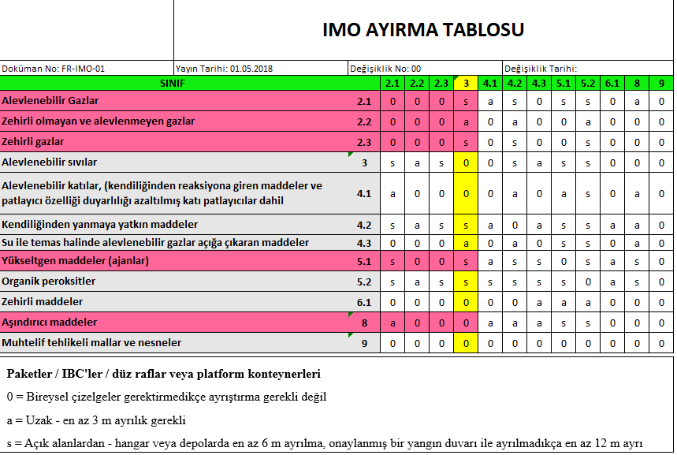
SORTING TABLE FOR PORT AREAS

The cleaning of containers and portable tanks carrying dangerous goods should be carried out in special areas away from the places where dangerous goods are stored. These areas should be adequately prepared and equipped in order to prevent the washing water contaminated by dangerous goods from mixing with the soil, water channels and sewer system.

After the container with scattered and unplaced dangerous goods is unloaded for delivery (unloading/stripping the cargo from the container), all plates and risk identifications of the cargo must be removed from the container.

4.5.1 Segregation Rule to be Applied in the Truck Parking Area:

Trucks carrying dangerous goods that will be temporarily parked in the truck parking area must be at least two parking space distances from another vehicle carrying dangerous goods.

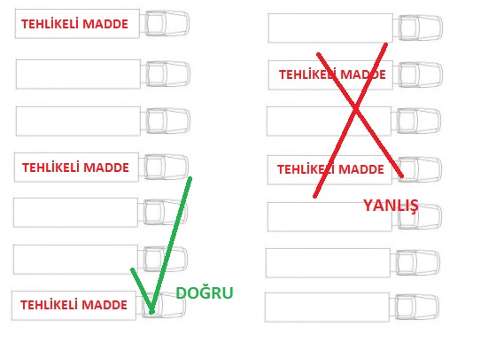

4.6 Hazardous cargo documentation:

Documents relating to dangerous goods handled in our port must comply with IMDG Code and other relevant legislative provisions. Documentation and documentation requirements for hazardous substances The IMDG Code is explained in detail in section 5. Hazardous materials which do not have the required documentation and are not provided in the proper manner are not processed. All costs incurred for such dangerous goods are subject to freight charges.

The documentation, control and recording tasks and operations related to dangerous substances are detailed in Part 7 of these Guidelines.

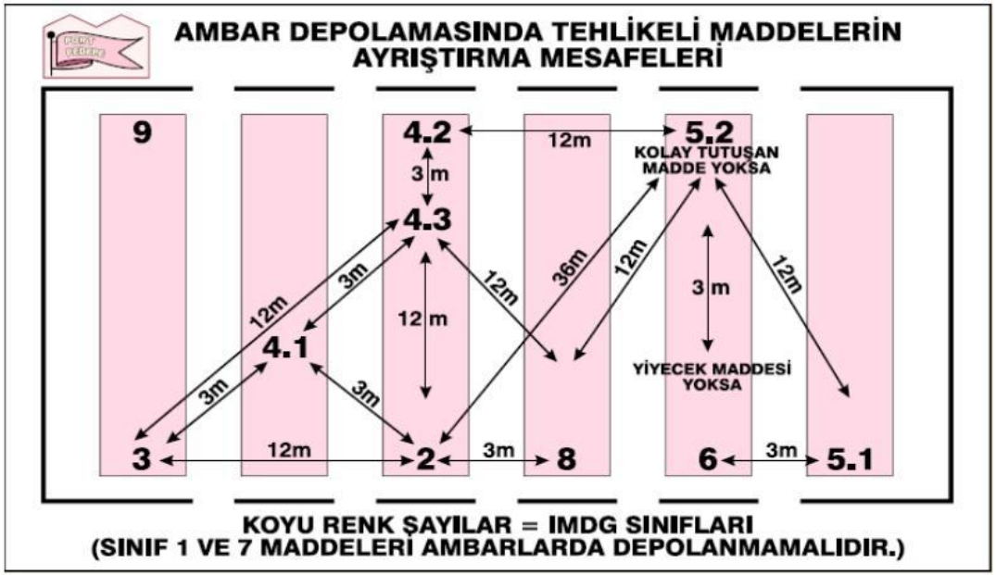

The IMDG Code uses four different storage terms:
- “Keep apart” (the minimum separation distance between two incompatible substances)
- “Stow separately”
- “Stow separately by a complete division or in separate locations”
- “Stow separately by a complete division longitudinally or in separate locations” (the maximum distance at which two incompatible substances are to be kept apart)
General provisions regarding the segregation of dangerous goods between different classes are indicated in the following Segregation Table.

SINIF |  | 1.1  1.2  1.5 | 1.3  1.6 | 1.4 | 2.1 | 2.2 | 2.3 | 3 | 4.1 | 4.2 | 4.3 | 5.1 | 5.2 | 6.1 | 6.2 | 7 | 8 | 9
Explosives | 1.1, 1.2, 1.5 | * | * | * | 4 | 2 | 2 | 4 | 4 | 4 | 4 | 4 | 4 | 2 | 4 | 2 | 4 | X
Explosives | 1.3, 1.6 | * | * | * | 4 | 2 | 2 | 4 | 3 | 3 | 4 | 4 | 4 | 2 | 4 | 2 | 2 | X
Explosives | 1.4 | * | * | * | 2 | 1 | 1 | 2 | 2 | 2 | 2 | 2 | 2 | X | 4 | 2 | 2 | X
Flammable gases | 2.1 | 4 | 4 | 2 | X | X | X | 2 | 1 | 2 | X | 2 | 2 | X | 4 | 2 | 1 | X
Non-toxic, flammable gases | 2.2 | 2 | 2 | 1 | X | X | X | 1 | X | 1 | X | X | 1 | X | 2 | 1 | X | X
Toxic gases | 2.3 | 2 | 2 | 1 | X | X | X | 2 | X | 2 | X | X | 2 | X | 2 | 1 | X | X
Flammable liquids | 3 | 4 | 4 | 2 | 2 | 1 | 2 | X | X | 2 | 1 | 2 | 2 | X | 3 | 2 | X | X
Flammable solids (including self-reactive substances and desensitized explosives) | 4.1 | 4 | 3 | 2 | 1 | X | X | X | X | 1 | X | 1 | 2 | X | 3 | 2 | 1 | X
Self-heating substances | 4.2 | 4 | 3 | 2 | 2 | 1 | 2 | 2 | 1 | X | 1 | 2 | 2 | 1 | 3 | 2 | 1 | X
Substances that emit flammable gases upon contact with water | 4.3 | 4 | 4 | 2 | X | X | X | 1 | X | 1 | X | 2 | 2 | X | 2 | 2 | 1 | X
Oxidizing substances (agents) | 5.1 | 4 | 4 | 2 | 2 | X | X | 2 | 1 | 2 | 2 | X | 2 | 1 | 3 | 1 | 2 | X
Organic peroxides | 5.2 | 4 | 4 | 2 | 2 | 1 | 2 | 2 | 2 | 2 | 2 | 2 | X | 1 | 3 | 2 | 2 | X
Toxic substances | 6.1 | 2 | 2 | X | X | X | X | X | X | 1 | X | 1 | 1 | X | 1 | X | X | X
Infectious substances | 6.2 | 4 | 4 | 4 | 4 | 2 | 2 | 3 | 3 | 3 | 2 | 3 | 3 | 1 | X | 3 | 3 | X
Radioactive material | 7 | 2 | 2 | 2 | 2 | 1 | 1 | 2 | 2 | 2 | 2 | 1 | 2 | X | 3 | X | 2 | X
Corrosive substances | 8 | 4 | 2 | 2 | 1 | X | X | X | 1 | 1 | 1 | 2 | 2 | X | 3 | 2 | X | X
Miscellaneous dangerous substances and mixtures | 9 | X | X | X | X | X | X | X | X | X | X | X | X | X | X | X | X | X
(This table applies to consolidated dangerous goods; for pallets, drums, boxes, crates, and similar packages. It does not apply to containers carrying dangerous goods.)
As defined in this section, the numbers and symbols relate to the following conditions:
1 | Keep apart | 3 meters
2 | Stow separately | 6 meters
3 | “Stow separately by a complete division or in separate locations” | 12 meters
4 | “Stow separately by a complete division longitudinally or in separate locations” | 24 meters
X | If segregation is required, it is indicated in the Dangerous Goods List | -
Explosives require special storage according to their compatibility group. Regardless of their class division, explosives with the same letter may be stacked together. Even if the substance, material, or properties of products within the same class vary greatly, it is important in all cases to first consult the Dangerous Goods List to determine the appropriate segregation requirements.

MANUAL FOR DANGEROUS CARGOES HANDLED ON SHORE FACILITY

Port facility which carries out loading/discharge, handling and temporarily storing of dangerous goods, contributes to make the activities in a safe condition;

- Dangerous goods classes,
- Dangerous goods packages,
- Packaging,
- Labels,
- Marking and packaging groups,
- Segregation tables for dangerous goods on board and port according to classes,
- Segregation distance of dangerous goods in sheds storages,
- Segregation terms,
- Dangerous goods documents,
- Dangerous goods emergency response action flowchart,

Are the same as in Dangerous Goods Manual Annex-10.

OPERATIONAL ISSUES

Procedures for berthing, mooring, loading/discharging, harbouring or anchoring of ships transporting dangerous goods at night and day in a safe condition:

- Ships transporting dangerous goods will be gone alongside to port berths by pilotage and tugboats preferably during day, during night if allowed by Port authority, in accordance with Port Regulations.
- Harbor Pilot will be informed about the dangerous goods aboard ship before maneuver.
- Positions of ship transporting dangerous goods must be considered, berthing must be planned after removal of ship in case of risk.
- In the event that practice of Master for mooring is deemed unsafe for port, it should be requested from Master to connect the ship by extra ropes.
- In case of unfavorable weather conditions, flows and winds create unsafe condition for loading/discharging, the activity must be stopped and the ships must be removed and taken to the anchorage.
- Anchorage sites are different for the ships transporting dangerous goods; ship can wait in the anchorage sites designated for them.

Procedures for additional measures taken for loading, discharging and transshipment of dangerous goods according to seasonal conditions.

- Seasonal conditions must be considered for loading and discharging of the dangerous goods. Handling flammable, combustible, explosive goods should be postponed or stopped at extreme heat, extreme cold, extreme rainy and weather with unfavorable sight conditions, lighting and weather with electric power load.
- If loading/discharging in unfavorable conditions have to be continued or in mandatory conditions; fire, fire department, emergency response teams must be kept in order to response to unwanted conditions as soon as possible.
- In case of continuity of similar conditions, measures, such as the workers must be elected from the experienced ones, resting periods must be planned frequently in extremely hard working situation, increase the lighting, etc. must be provided.

Procedures for keeping away flammable, combustible and explosive materials from spark producing operations and procedures for not operating vehicles, equipment and tools capable of spark-production in area of dangerous goods handling, stowing and storing are made.

- Berthed in the state, with load deck and the point of smoking in dangerous cargo vessels carrying hazardous cargo coast of storage space, lighting a fire, it is forbidden to work as welding sparks.
- Flammable materials are kept away from spark-forming process and can not be operated cargo handling dangerous tools or instruments that make up the field of spark.
- In dangerous cargo fields, while handling dangerous goods, working with especially flammable, combustible and explosive ;
- Not doing hot work (welding, cutting, etc), technical safety measures must be taken in case of mandatory cases,
- Ex proof hand tools must be used,
- Working with experienced personnel,
- Relevant units must be informed before work,
- Briefing will be given to the personnel working in the field,
- Especially in closed area of working, measurement of toxic, choking gases and sufficient oxygen must be done, the measurement device must be ready to use.
- Protective measures and equipment such as water curtain, protective separation, mechanical ventilation must be ready to use.
- The personnel working in Hot Work must wear necessary protective clothing and equipment, closed circuit breathing apparatus when required.
- Emergency team must be assigned to response as soon as possible in potentially undesirable situation in this kind of working.

DOCUMENTATION, CONTROL AND RECORD

7.1 Procedures related to all required documents, information and papers, their provision and control by the authorities.

The following documents related to Dangerous Goods are kept by Shore facility livingly.

- IMDG CODE Volume 1, 2 and ANNEX Book
- IMSBC CODE, International Maritime Solid Bulk Cargoes Code
- Blu Code and Blue Manuel

In order to handle the dangerous goods transported to facility in a safe condition and to take the required measures, Shore facility needs documents sent prior. The documents are as follows:

ı. Dangerous Freight Notification Certificate
ii. MSDS (Material Safety Data Sheet)
Iii. Documents Required on Board
Iv. Other Required Documents and Information

Dangerous Goods Transport Document:

The shipping documents prepared by the shipper shall include a "Signed Certificate or Hazardous Load Notification Document" stating that the shipment to be transported is properly packed, marked, labeled, and in good condition for shipment.

The vessel carrying the dangerous cargo and the sea vessel must be at least twenty four hours before entering the port administrative area; Ships and marine vessels that are less than twenty-four hours of cruising time to enter the port area shall submit the notification document in writing to the port headquarters by the relevant authorities, with detailed information on their cargo immediately after the departure from the coastal facility.

The cargo concerned must notify the coastal installation at least 3 hours before entering the coastal facility with regard to dangerous cargo arriving by road and rail.

Failure to comply with the notification obligation, or if the notifications do not contain accurate information, administrative action may be taken against the notifier and, if any, may lose the order of docking, departure, or transit.

When the Dangerous Freight Notification Document is provided with the EDP (Electronic Data Processing) or EDI (Electronic Data Exchange) techniques, the sender information will be available in a timely manner as a printed document in the required order in this section.

Dangerous Load Notification Document The IMDG Code may be in any form provided that it contains all the information specified in Section 5.4.

7.1.2.2 Container / Vehicle Packing Certificate :

If the dangerous goods are loaded or packaged into any container or vehicle, those responsible for packing / loading the container or vehicle will provide a "container / vehicle packing certificate" which will indicate that the container / vehicle identification number and the procedures performed are in accordance with the following:

- The container / vehicle must be clean, dry and suitable for the appearance of dangerous goods,
• Whether the packages that need to be segregated according to the applicable separation requirements are packed together and / or not loaded / unloaded /
• All packages are inspected for external damage, only robust packages are installed,
• Unless otherwise specified, the barrels are stacked vertically, all materials are properly loaded and, if necessary, wrapped with the binding material necessary to comply with the intended transport pattern (s)
• Bulk loaded materials are loaded uniformly in the container / vehicle,
• Container / vehicles and packages; Properly labeled and appropriately labeled, labeled and labeled,
• If solid carbon dioxide (CO2-dry ice) is used for cooling purposes, the container / vehicle must be properly branded,
• For each hazardous item loaded into the container / vehicle, the Dangerous Freight Notification document,

"Note: There is no need for container / vehicle packing certificate for portable tanks."

The information required in the Dangerous Load Notification Document and the container / vehicle packing certificate can be collected in a single document. If this is not the case, the documents will be added together. If there is only one document, there will be a signed declaration under the document: "the packing of the materials loaded in the container / vehicle is made according to the appropriate provisions." This notification will be dated and the identity of the signer will be documented.

Signature (s) may be electronic signature (s) if the container / vehicle packing certificate is provided with EDP or EDI sending techniques, or may be replaced by the name (capital letters) of the person or persons authorized to sign.

When a container / vehicle packing certificate is provided to a carrier via EDP or EDI techniques and then the dangerous goods are transferred to a carrier with a printed hazardous materials transport document, the carrier will be sure that the printed document specifies the information "Received electronically" and written in capital letters of the signer's name.

7.1.2.3 Documents to be found on board :

Each ship carrying hazardous materials and marine pollutants will have a specific list, manifesto or stack plan for the names and locations of dangerous substances and marine pollutants. This specific list and manifest will be based on the documents and certificates required in the IMDG Code.
A detailed stacking plan of the class, which shows the locations of all the dangerous substances and sea pollutants, will be used instead of this specific list or manifesto.
For sending dangerous goods; Appropriate information will be available at any time to be used for any accidents related to dangerous goods during the transportation and emergency intervention to be carried out. This information will be away from packages containing dangerous substances and will be immediately available in case of an incident. Information to be used in emergency intervention will be found in the following documents.

• Within a special list, manifest or hazardous substance declaration,
• Within a separate document such as the safety data sheet,
• Separate documents such as the Medical First Aid Guide (MFAG) for use in Accidents involving Hazardous Materials and Emergency Response Procedures for Emergency Procedures for Vessels carrying Hazardous Substances (EMS Guideline) to be used in conjunction with the transport document.

Other required information and documents

In certain cases, the following special certificates or documents will be required.
• An air wear certificate, as requested on certain entries in the Dangerous Goods List.
• Material, material or object; A certificate that excludes IMDG provisions (such as charcoal, fish meal, see separate entrances for seed tub);
• A notification made by the competent authority of the country of origin about approved classification and transport conditions for new formulations of new self-reactive substances and organic peroxides or currently allocated self-reactive substances and organic peroxides.

Multimodal Dangerous Goods Form

Multimodal Dangerous Goods Form is a form which is used as a combined dangerous goods declaration regarding transportation of dangerous goods in multiple modes and container packing certificate.

Example of Multimodal Dangerous Goods is in Annex-18.
Procedures for proper and full keeping updated list of dangerous goods in shore facility area and other information :

Port facility is obliged to submit the information about class, quantity, emergency response methods and locations of all dangerous goods in port facility, to the authorities upon request at any time.

Operation Department will keep the records involving the following information of the dangerous goods handled in our port.
- UN Number,
- PSN name ( Proper Shipping Name),
- Class, (Class 3, 4.1, 4.2, 4.3, 5.1, 6.1, 8, 9 with sub-dangers )
- Packing group (I; II; III)
- Marine Pollutant feature,
- Consignee,
- Shipper,
- Container / Packing number,
- Seal number,
- Additional Information (Ignition temperature, viscosity, etc. )
- Storage Location in Port Field
- Duration of stay in Port

This information is kept under computer or file as only reached by authorized personnel, shown upon request.

Port facility keeps the updated records of dangerous goods about class, quantity, which have been handled throughout the year by the port and notifies them to Port authority in 3 months period.

7.2 Procedures for Keeping the Up-to-Date List of All Dangerous Goods in the Coastal Facility Site and Other Related Information Regularly and Completely:

When requested, the port facility is obliged to provide information about the class, quantity, emergency response methods and locations of all dangerous cargoes available at the port facility when requested.

The records of dangerous goods handled at our port will be kept by the operations department, including the following information.

o UN Number,
o PSN name (Proper Post Name),
o Class (with Sub-hazards),
o Packing Group (Class I,II, III),
o Whether it is a Marine Pollutant,
o Buyer,
o Sender,
o Container/Packaging, its number,
o Seal number,
o Additional Information (Ignition degree, viscosity, etc.),
o Where it is stored in the port area,
o Length of stay in the port,

This information is kept in a computer environment or in a file order so that only authorized personnel can access it and is displayed when requested.

The port facility keeps up-to-date the class and quantity information of the dangerous goods it handles throughout the year and reports it to the port authority in quarterly periods.

Procedures for control of proper identification of dangerous goods in the facility, using proper shipping names, certificating, packaging/packed, labeling and declaring of dangerous goods, loading to approved package, container or good cargo transport unit in accordance with rules and transporting in a safe condition and reporting the results of control.

Planning department checks the accuracy of the following information on dangerous goods documents issued by the shipper in coordination with operation about the dangerous goods to be received to port;
- UN Number,
- PSN name (Proper Shipping name),
- Class, (Class 3, 4.1, 4.2, 4.3, 5.1, 6.1, 8, 9 with sub-dangers)
- Packing Group ( I; II; III)
- Marine Pollutant feature,
- Container / packing number,
- Seal number,
- Additional information (Ignition temperature, viscosity, etc.)
- Storage Location in Port Field,

This information is delivered to the tally clerk, Field Supervisors, Storage officers, HSE and to the staff who requires knowing the information, by sending upon terminals/documents, so the control of dangerous goods is provided.
In the event that information from operation conflicts with information of goods, operation shall be informed immediately, shipper is directed to confirm the information dangerous goods cargo/vehicle/container, correct the deficient and wrong label marks if any.

Procedures for obtaining and keeping dangerous goods safety information form (SDS).

Dangerous Goods Safety Information Form (SDS) involving the following information is required for dangerous goods transported by all modes of transportation (Road, rail, air and marine) according to our national law since 1 January 2014.
- UN number,
- PSN (Proper shipping name,) (required for marine transport. )
- Class, (Class 3, 4.1, 4.2, 4.3, 5.1, 6.1, 8, 9 with sub-dangers)
- Packing group (I; II; III)
- Marine pollutant feature,
- Tunnel Restriction Code (required for road transport. )

In port, there is a check to control this document together with the dangerous goods to be received.

Procedures for keeping records and statistics of dangerous goods.

A report containing information on hazardous cargo handled by the Administration in our port facility was requested to be reported to the Port Authority in 3-month periods.

Statistical evaluation from records of dangerous goods handled in our port annually is prepared by trade, operation departments.

Monthly inventory and control reports of dangerous goods stored in the port are issued by operation department and submitted to the Management.

Records and reports are archived by the departments in 5 year periods.

Information on Quality Management System.

The Quality Management Systems installed in our port are given below.

• ISO 9001 (Quality Management System)
• ISO 14001 (Environmental Management System)
• ISO 45001 (Occupational Health and Safety Management System)

EMERGENCIES, PREPAREDNESS FOR EMERGENCİES AND RESPONSE

Response procedure for dangerous goods that endangers/able to endanger life, property and/or environment and dangerous incidents involving dangerous goods :

Hazardous cargoes coming into, being handled, stored, picked up and discharged from coastal facilities pose specific risks such as explosion, fire, abrasion, poisoning, infectious disease, radiation. For this reason, there are many kinds of emergency situations that the coastal facility will face. It is crucial to develop, publish and implement the Emergency Action Plan in partnership with local emergency teams in order to be able to deal with these hazards.

8.1.1 The following points shall be taken into account in the establishment of the emergency strategy at coastal facilities.

• Prevention of Accidents
• Preparation of the Emergency Action Plan
• Implementation and Exercise of Emergency Procedures
• Regular Control of Emergency Equipment
• Implementation of the Plan when an Emergency Situation Occurs
• Analyze and report the case thoroughly to prevent duplication

8.1.2 Procedures for Intervention in Hazardous Situations involving hazardous substances and dangerous substances that may create / create risks to the property,

Intervention in dangerous situations will be done according to the Urgent Action Plan prepared by our facilities.

Information for possibility, capacity and capability of shore facility to response emergencies.

Possibility, capability and capacity of fire response :

The emergency plan is detailed in chapter 8, inventory of resources, equipment and equipment to be used for emergency response.

Possibility, capability and capacity for leakage and spillage.

There are two 40 feet portable and fixed container leakage pools.

Regulations of first response for accidents involving dangerous goods.

Accidents, which are occured by dangerous goods in our shore facility are, in form of fire and flow/leakage/spillage.

The measures against fire which is occured by dangerous goods are as follows:
- In case of fire which is occured as a result of accident involving dangerous goods that are handled in port facility, Emergency Plan (EMS) annexed to IMDG Code shall be considered.
- Measures in emergency plan, which are taken for fire, are generally as follows.

  - F-A(General Fire Plan)
  - F-B(Explosive Substances and Articles)
  - F-C(Non-Flammable Gases)
  - F-D(Flammable Gases)
  - F-E(Non-Water-Reactive Flammable Liquids)
  - F-F(Temperature-Controlled Self-Reactives and Organic Peroxides)
  - F-G(Water-Reactive Substances)
  - F-H(Oxidizing Substances with Explosive Potential)
  - F-I(Radioactive Material)
  - F-J(Non-Temperature-Controlled Self-Reactives and Organic Peroxides)

The measures taken against flow/leakage/spillage which are occured by dangerous goods are as follows:
- In case of flow/leakage/spillage which are occured as a result of accident involving dangerous goods that are handled in port facility, Emergency Plan (EMS) annexed to IMDG Code shall be considered.
- Measures in emergency plan, which are taken for flow/leakage/spillage, are generally as follows:
  - S-A(Toxic Substances)
  - S-B(Corrosive Substances)
  - S-C(Flammable, Corrosive Liquids)
  - S-D(Flammable Liquids)
  - S-E(Flammable Liquids, Floating On Water)
  - S-F(Water-Soluble Marine Pollutants)
  - S-G(Flammable Solids and Self-Reactive Substances)
  - S-H(Flammable Solids “Molten Material”)
  - S-I((Flammable Solids “Repacking Possible”)
  - S-J(Wetted Explosives and Certain Self-Heating Substances)
  - S-K(Temperature-Controlled Self-Reactive Substances)
  - S-L(Spontaneously Combustible, Water-Reactive Substances)
  - S-M(Hazard of Spontaneous Ignition)
  - S-N(Substances Reacting Vigorously with Water)
  - S-O(Substances Dangerous When Wet “Non-Collectable Articles”)
  - S-P(Substances Dangerous When Wet “Collectable Articles”)
  - S-Q(Oxidizing substances)
  - S-R(Organic Peroxides)
  - S-S(Radioactive Material)
  - S-T(Dangerous Goods with Biohazard)
  - S-U(Flammable, Toxic or Corrosive Gases)
  - S-V(Non-Flammable, Non-Toxic Gases)
  - S-W(Oxidizing Gases)
  - S-Y(Explosive Chemicals)
  - S-Z(Toxic Explosives)

The Medical First Aid Guide (MFAG) will be used for accidents involving dangerous substances. Things to note when using the Guide are as follows.

• When exposed to a dangerous substance, emergency action will be taken first.
• The medical first aid guide will be applied in 3 steps.

Step 1: Emergency response and diagnosis Start here!

Step 2: Consider the tables. Tables special cases
Short instructions for
It contains.

Step 3: Consider Attachments Attachments of drugs and exposure
Remainable
About chemicals
Contains detailed information.

Use the following table while emergency action.

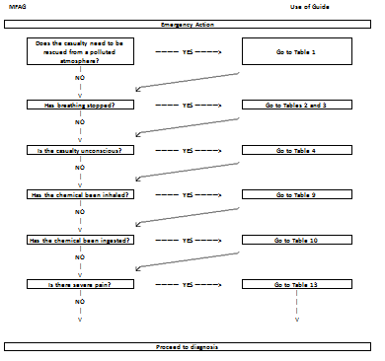

Use the following table for diagnosis.

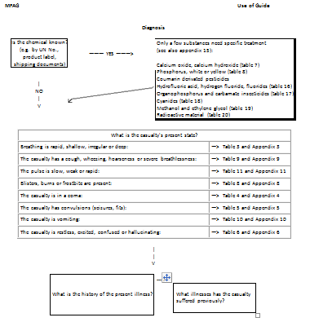

8.3.6 Tables involves special conditions for special conditions, the information for tables are as follows.

Table 1 : Rescue
Table 2 : Cardio-Pulmonary Resuscitation (CPR)
Table 3 : Oxygen Administration and Controlled Ventilation
Table 4 : Chemical-Induced Distrubances of Consciousness
Table 5 : Chemical-Induced Convulsions
Table 6 : Toxic Mental Confusion
Table 7 : Eye Exposure to Chemicals
Table 8 : Skin Exposure to Chemicals
Table 9 : Inhalation of Chemicals
Table 10: Ingestion of Chemicals
Table 11: Shock
Table 12: Acute Kidney Failure
Table 13: Pain Relief
Table 14: Chemical-Induced Bleeding
Table 15: Chemical-Induced Jaundice
Table 16: Hydrofluoric Acid and Hydrogen Fluoride
Table 17: Organophosphate and Carbamate Insecticides
Table 18: Cyanides
Table 19: Methanol and Ethylene Glycol
Table 20: Radioactive Material

8.3.7 The Appendices provide comprehensive information, medicines and chemicals that might be exposed. Information on appendices are as follows.

Appendix 1 : Rescue
Appendix 2 : Cardio-Pulmonary Resuscitation (CPR)
Appendix 3 : Oxygen Administration and Controlled Ventilation
Appendix 4 : Chemical-Induced Distrubances of Consciousness
Appendix 5 : Chemical-Induced Convulsions
Appendix 6 : Toxic Mental Confusion
Appendix 7 : Eye Exposure to Chemicals
Appendix 8 : Skin Exposure to Chemicals
Appendix 9 : Inhalation of Chemicals
Appendix 10: Ingestion of Chemicals
Appendix 11: Shock
Appendix 12: Acute Kidney Failure
Appendix 13: Pain Relief
Appendix 14: List of Medicine and Equipment
Appendix 15: List of Materials

Notification to be made inside and outside of facility in emergencies.

Flowchart for notification to be made in emergencies are as follows.

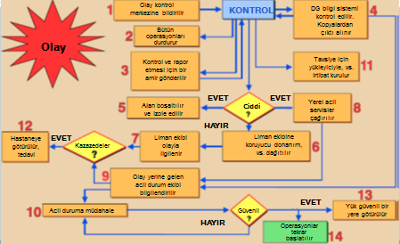

Notification required to be made in our shore facility is the same as in Hazardous Material Emergency Action Plan.

Procedures for reporting accidents.

Accidents / incidents involving dangerous cargo in our premises will first be reported to the Harbor Master within 3 hours from the moment of use, using the VHF radio system or other means of communication. Following this declaration, a written report containing the opinion of the accident / event shall be sent to the port authority within 24 hours at the latest.

Coordination, support and cooperation method with public authorities.

Coordination, support and cooperation method with public authorities is the same as in Emergency Action Plan.

Ships and emergency evacuation plan for the removal of the emergency vehicles in the coastal resort of sea

Available. Presented to the Port Authority

Damaged dangerous loads with procedures for handling and disposal of wastes contaminated with dangerous cargo

For each dangerous cargo to be handled at our facility, the instructions given in these forms will be complied with for the handling and disposal of damaged hazardous cargoes and hazardous cargoes according to the Material Safety Data Sheet (SDS).

Emergency drills and their records:

Training required to be taken by people in charge of dangerous goods operations will be implemented as indicated below.

Each person engaged in transport or handling of dangerous goods should take training for transport or handling of dangerous cargo in a safe condition commensurate with their responsibilities.

Shore-based personnel, should take training general awareness/familiarization training, function-specific training and safety training. These people could be stated as follows:

Classifying the dangerous goods and identifying the Proper Shipping Names of Dangerous goods;

Packing the dangerous goods ;

Marking or labelling the dangerous goods;

Opening/closing the packages of cargo transport units;

Preparing transport documents for the dangerous goods;

Offering the dangerous goods for transport;

Receiving or taking the dangerous goods for transport;

Handling the dangerous goods on transport;

Preparing the plans for loading/stowage the dangerous goods;

Loading/discharging the dangerous goods into/from ships;

Carrying the dangerous goods in transport;

Inactivating the cargo storages;

Measuring the cargo storage and taking samples;

Washing the cargo storages in accordance with approved procedures and regulations;

Enforcing, surveying or inspecting legal requirements, rules and the compliance with regulations

Involving in any other way into the transport of dangerous goods as determined by Competent Authority.

The content of training required for people engaged in dangerous goods is as follows.

General awareness / familiarization training:

Each person should take training for safe shipment or handling of dangerous cargo commensurate with responsibilities. Training must be designed to ensure the familiarization of general dangers and legal requirements of dangerous cargoes. This training must involve identification of types and classes of dangerous cargoes, labelling, marking, packaging, segregation and compliance with requirements; a description of purpose and content of dangerous goods transport documents and a description of available emergency response documents.

Function-specific training:

Each person shall be trained in specific dangerous goods transport provisions about the safe shipment or handling of dangerous cargo which is applicable to the function that person performs.

Safety training:

Each person should receive training about the following issues regarding risks in the occurrence of a release of dangerous cargoes and the function performed:

- methods and procedures for accident avoidance about proper use of package handling equipment and appropriate methods of stowage and segregation of dangerous goods;

- available emergency response information and how to use it;

- general dangers presented by the various types and classes of dangerous goods and how to prevent exposure to those hazards, including, if appropriate, the use of personal protective clothing and equipment; and

- emergency procedures to be followed in the event of an unintentional release of dangerous goods, including any emergency response procedures for which the person is responsible and personal protection procedures to be followed.

Records regarding the training of people in charge of dangerous goods:

Records of all security training undertaken should be kept by the Port Facility Management and given to the worker if requested.

Personnel working in dangerous cargo operations in the port area are provided with training in accordance with their job descriptions within the scope of the Directive on IMDG Code Training Seminars published with the Minister's Approval dated 26/7/2019 and numbered 56617. Informing and controls are carried out for subcontractor personnel to receive training in this context.

8.9.4 Drills and record regarding to dangerous goods.

- Drill implementation ; In order to be ready for emergencies in facility, personnel in emergency organization are prepared for their duties by various training. Trainings must be done by support of specialized organization when necessary. In this context, relevant personnel get IMDG code training regarding to dangerous goods and certificated in the port. It should be planned to carry out and implement the drills according to the worst-case scenario in order to test the adequacy of emergency plans and be ready for real incidents.
- Drill Scenarios; The worst scenario must be foreseen as one incident or a combination of incidents faced by port in exercise planning. Exercises are provided to implement in line with prepared scenarios in fastest and most efficient way.
- Emergency Drills to be held within port facility;
- It should be stated in Port annual training plans.
- IT can be planned as local or general response,
- It can be combined with Safety, Spilling, etc exercise scenarios,
- Drills can be made by/without informing.
- Drills are based on various emergency scenarios.
- Drills can be made actually, or desk bound, seminar type,
- Scenarios with different time, day, season and incident are prepared for each drill.

8.10 Information on Fire Protection Systems :

In our facility, hydrants, fire foam machines, portable fire extinguishers are available under fire protection systems. Information on fire protection systems is as in 8.2.1.

8.11 Procedures for Approval, Inspection, Testing, Maintenance and Use of Fire Protection Systems :

Periodic controls are carried out regarding the approval and inspection of fire protection systems in our facility.

Testing, maintenance and use of fire protection systems are made weekly and monthly by our facility and processed into control forms.

Measures to be taken when fire protection system not working :

In case the fire protection system does not work in our facility, firstly it will be tried to utilize from neighbourhood and adjacent facilities, then local fire department will be informed. Response to incident will be carried out by using all capacity of region.

Other risk controlling equipment :

There is no other risk controlling equipment.

OCCUPATIONAL HEALTH AND SAFETY

Purposes of Occupational Health and Safety Measures:
The purposes of the occupational health and safety are as follows;

- To protect employees:
It is the main purpose of the occupational health and safety. It aims to protect the employees against working accidents and occupational diseases, provide the mental and physical integrity.

- To provide production safety:
It is important for economy as providing production safety in workplace will lead an increase in efficiency.

- To provide facility safety:
As the measures taken in workplace remove the dangers in facility due to machinery malfunctions and disabled operations, explosions, fire which may arise from working accidents or unsafe and unhealthy working conditions, the facility safety can be ensured.

Information on personal protective clothing and procedures for their use

Personal protective clothing is in the specified standards and these clothes are like the ones in Appendix-15 which indicate who wears these clothes.
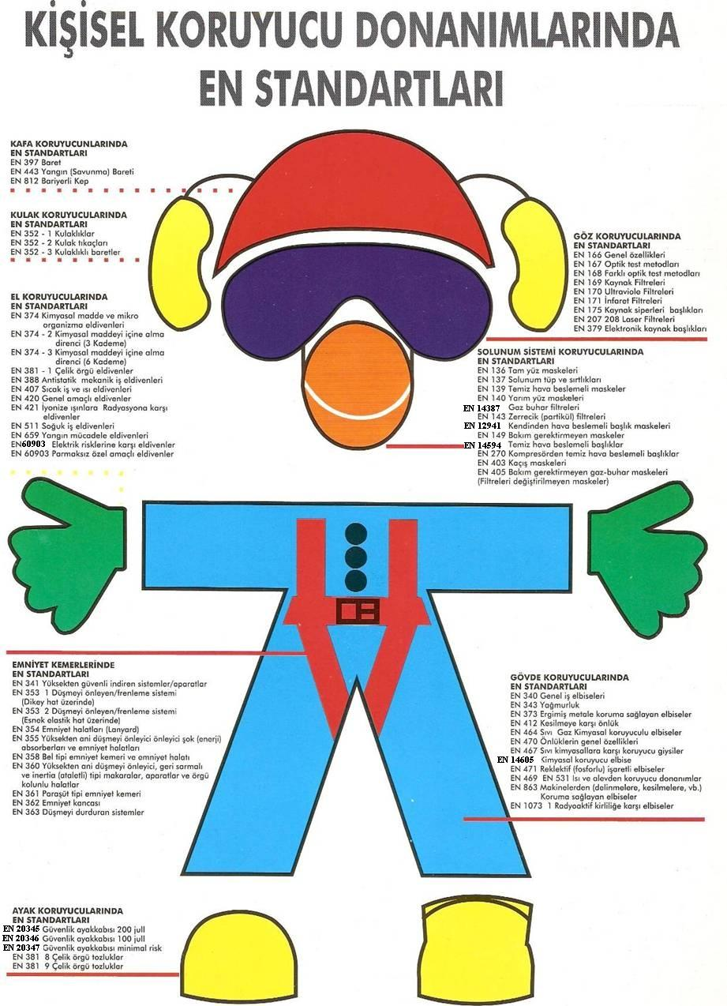

Closed Space Entry Permit Measures and Procedures:

The Shore Facility has a closed area working procedure covering dangerous cargo handling operations in cargo zones and similar areas on all bulk and general cargo ships. Dangerous solid bulk cargoes are not stored indoors.

The general application is as follows;

No one should open or enter a confined space unless authorized by the master or the authorized responsible person and appropriate safety procedures established for a particular ship are followed.
Entrance doors or hatches leading to confined spaces should always be secured against entry when entry is not required.
Such accidental conditions, such as a rope or chain placed with a warning sign placed opposite the opening, where a door or hatch cover opened to allow natural ventilation of an enclosed space may be falsely perceived as an indication of a safe environment and therefore the attendant may be present at the entrance or the use of mechanical barriers. can prevent entry.

The ship's master or responsible person must ensure the safety of the confined space;

1. Potential hazards have been identified in the relevant confined space assessment and have been isolated or made as safe as possible,
2. The area must be fully ventilated by natural or mechanical means to remove toxic or flammable gases and to ensure adequate oxygen levels throughout the entire environment,
3. have been suitably tested with appropriately calibrated instruments to detect acceptable levels of oxygen and acceptable levels of flammable or toxic vapors,
4. The area must be secured for entry and suitably lit,
5. An appropriate communication system between all parties for use at site entry must be agreed and tested,
6. An officer should be instructed to remain at the entrance of the area for as long as it is occupied, rescue and resuscitation equipment should be located at the entrance to the area ready for use, and rescue arrangements agreed. (The precautions in this clause may not apply to all situations described in this section. The person granting access must determine whether a guard is required and whether it is necessary to position rescue equipment at the site entrance.)
7. Personnel entering the area should be appropriately equipped with protective clothing and PPE for entry and subsequent duties.

OTHER ISSUES

Validity of Dangerous Goods Compliance Certificate :

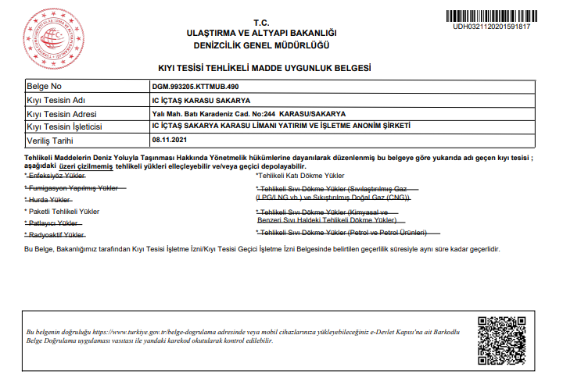10.2 Dangerous Goods Security Advisor Task Description :

Monitor compliance with the requirements for the transport of dangerous goods.

Providing recommendations to the coastal facility for the transport of dangerous goods.

Prepare an annual report to the coastal facility regarding the activities of the coastal facility operator in the transport of dangerous goods. (Annual reports will be kept for 5 years and submitted to the registrar upon request).

• Controls the following practices and methods ;

Controlling of identifying, using the proper shipping name, certificating, packing/packaging, labelling and declaring of dangerous goods, loading and transporting to the approved and appropriate packs, container and cargo transport units in a safe condition , and procedures for reporting control results.

Procedure for loading/discharge of dangerous goods handled and stored temporarily,

Whether taking into consideration of special requirements of shore facility about dangerous goods while buying the transport vehicles regarding to handled dangerous goods,

Control methods of equipment used for transporting, loading and discharging the dangerous goods,

Whether the shore facility personnel take appropriate training including the amendments in legislation, and whether the records are kept or not,

Compliance of emergency methods applied in case an accident or incident that affects safety during transporting, loading or discharging dangerous goods,

Compliance of reports prepared for serious accidents, incidents or serious violations occurred during transporting, loading or discharging dangerous goods,

Determination of required measures against repetition of accidents, incident or serious violation and evaluation of the implementation,

To what extent, considering rules about selection of subcontractors or third parties and dangerous goods carriage,

Determination whether the employee working in transporting, handling, storing and loading/discharging of dangerous goods, have detailed information about operational procedures and instruction,

Compliance of measures taken to be prepared for risks during transporting, handling, storing and loading/discharging of dangerous goods,

Procedures for what the required document, information and papers related to dangerous goods.

Procedures about berthing, mooring to shore facility, loading/discharging, harbouring or anchoring for ships transporting dangerous goods by day and at night.

Procedures about additional measures for loading, discharging and transshipment according to seasonal conditions.

Accuracy of information about ability, capacity and capability of shore facility for emergency response,

Compliance of regulations for first response to the accidents involving dangerous goods,

Procedures for handling and disposal of the damaged dangerous goods, wastes contaminated with dangerous goods,

Information about personal protective clothing and procedures for using them.

TMGD’s authorized within the scope of the IMDG Code prepare quarterly reports regarding their responsibilities determined in the Regulation on Maritime Transport of Dangerous Goods and Loading Safety.

10.3 Issues for carrier of dangerous goods to the shore facility /from the shore facility by land (documents to be kept by road vehicles during entrance/exit of port or shore facility field, equipment and tools kept by these vehicles; port field speed limits, etc.):

Documents required to be carried:

- Transport documents,
- Dangerous goods Transportation Driver Training Certificate (SRC-5),
- Identification card with photo in charge in vehicle (identity card, driving license or passport),
- Written instruction prepared by carrier to give to driver ,
- Multimodal Dangerous Goods Transportation Form for dangerous goods transported in multimodals,
- ADR conformity certificate for vehicles,
- Copy of transport permission document taken from related competent authority for Class1, class 6 and class 7 dangerous goods transportation,
- Dangerous Goods and Dangerous Waste Compulsory Financial Liability Insurance for vehicles carried out dangerous goods transportation,

Equipment and apparatus required to have in vehicles:

- Portable fire extinguishers,
- At least one chock of appropriate size to the wheel diameter and maximum mass for each vehicle,
- Two self-standing warning signs,
- Eye rinsing liquid,
- Warning vest,
- Portable lightening apparatus,
- A pair of protective gloves,
- Eye protection goggles,
- Emergency escape mask,
- Shovel,
- Drain seal,
- Collecting container

Speed limits in Port Area:

Speed limits determined by Port facility will be applied.

Issues regarding to the carriers of dangerous goods to coming the shore facility/leaving from shore facility by sea (exhibition of signals by ships and sea vehicles to the port or shore facility by day/at night, cold and hot working procedures aboard ship)

10.4.1 Day/night indications of vessels carrying dangerous goods and of seagoing vessels at the port or coastal facility :

The vessel arriving at the shore installation and bearing dangerous cargo shall have the international sign code "B" (Burak Sanjak) at night and 2 Fixed Red Lanterns at night.

10.4.2 Cold and Hot Working Procedures in Vessels with Hazardous Cargo in Coastal Facilities :

10.4.2.1 Ships carrying dangerous cargo at the coastal facility will receive the necessary permission from the Harbor Master for cold and hot work to be carried out and inform the coastal facility concerned

10.4.2.2 The principles of hot work to be carried out on vessels carrying dangerous cargo at coastal facilities are as follows.Additional issues added by shore facility.

Additional issues added by shore facility.

None.

ANNEXES
ANNEX-1
GENERAL LAYOUT OF SHORE FACILITY

ANNEX-2 PHOTO OF GENERAL APPEARANCE OF SHORE FACILITY
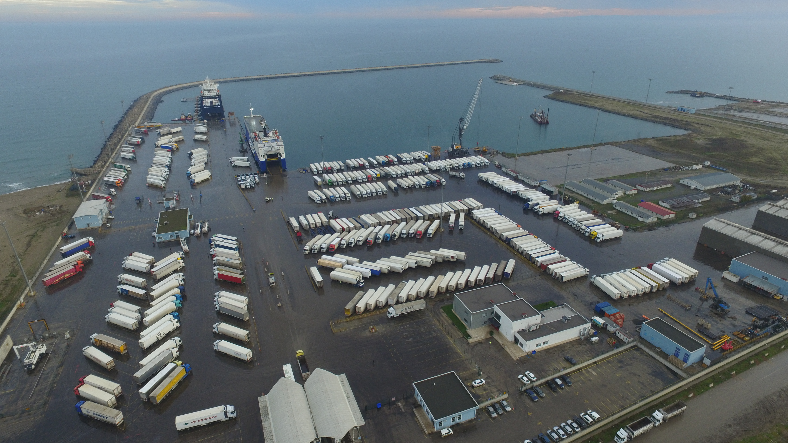

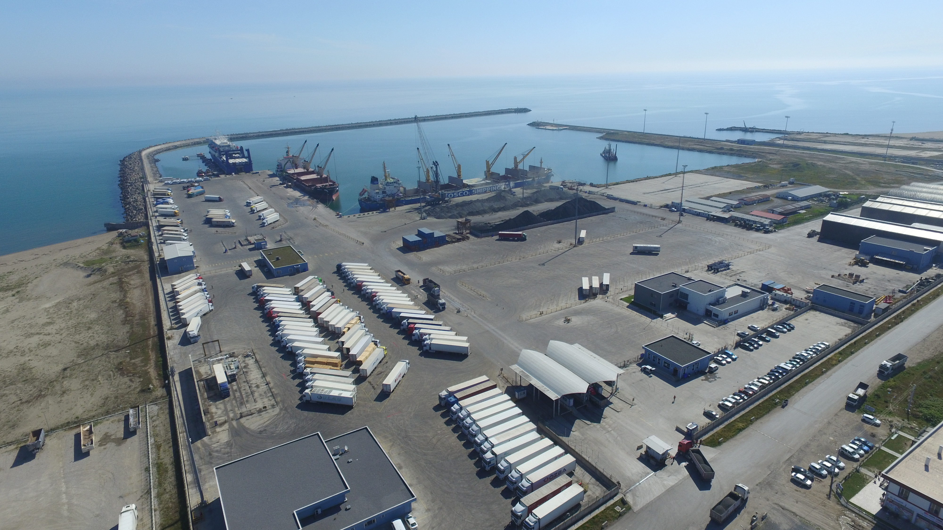

ANNEX-3
EMERGENCY CONTACT POINTS AND CONTACT INFORMATION
INSTALLATION

INSTITUTION | TELEPHONE
TC. Ministry of Transport, Maritime Affairs and Communications General Directorate for Hazardous Substances and Combined Transport | Phone : 0312-203 10 00  Fax : (0312) 231 33 06
Main Search and Rescue Coordination Center (MSRCC) | Phone : 0 312 231 91 05 (24 hours)  0 312 232 47 83 (24 hours)  Faks: 0 312 232 08 23  e-mail : trmc@denizcilik.gov.tr
General Directorate of Coastal Safety | Phone : 0 212 252 22 94  Fax : 0 212 292 52 97
Sakarya Governorship | Phone : 0 264 251 35 15  Fax : 0 264 251 35 19
Karasu District Governorate | Phone : 0 264 718 11 01  Fax : 0 264 718 11 03
Karasu Municipality | Phone : 0 264 718 12 00  Fax : 0 264 718 12 09
Karasu Port Authority | Phone : 0 264 718 12 30  Fax : 0 264 718 12 29
North Sea Area Command | Phone : 0 212 254 31 50
Coast Guard Marmara and Bosphorus Region | Phone : 0 212 242 97 10  Fax : 0 212 242 30 93
Sakarya Provincial Disaster and Emergency Directorate | Phone : 0 264 251 35 29  Fax : 0264 251 35 30
Karasu District Security Directorate | Phone : 0 264 718 11 52  Fax : 0264 718 11 50
Sakarya Provincial Security Directorate | Phone : 0 264 241 54 00
Karasu State Hospital Baştabipliği | Phone : 0264 718 11 43  Fax : 0264 718 45 04

3-1
KARASUPORT EMERGENCY TEAMS
SEARCH RESCUE AND EVACUATION TEAM
NUMBER | NAME | SURNAME |  | TITLE |  | PHONE NUMBER |  | SIGNATURE
1 | Süleyman | Oğur |  | Warehouse Manager |  | 0532 052 88 32
2 | Mert | Kopuz |  | Accounting Officer |  | 0533 015 70 74
3 | Sinan | Zengin |  | Team Leader Assist |  | 0531 901 83 81
4 | Kemal | Türker |  | Team Leader Assist |  | 0542 764 63 54
5 | Musa | Çakır |  | Maintenance |  | 0545 428 99 15
6 | Mesut | Kestane |  | Operator |  | 0534 454 41 98
7 | Tarık | Aktaş |  | Greaser |  | 0537 401 68 00
8 | Kenan | Fener |  | Chief Engineer |  | 0536 406 28 07
10 | Adem | Erdem |  | Security |  | 0530 447 62 54
FIRE FIGHTING TEAM
NUMBER | NAME |  | SURNAME |  | TITLE | PHONE NUMBER | SIGNATURE
1 | İbrahim |  | Karadağ |  | Team Leader | 0536 397 95 57
2 | Mustafa |  | Doğan |  | Operator-Üye | 0537 212 52 07
3 | Hasan |  | Çabuk |  | Liman işçisi | 0542 630 77 02
4 | Güven |  | Şentürk |  | Security | 0534 652 00 54
5 | Tarık |  | Aktaş |  | Security | 0543 719 85 70
6 | Köksal |  | Ekşi |  | Security | 0537457 58 09
7 | Samet |  | Kar |  | Security | 0532 065 17 27
8 | Murat |  | Talay |  | Security | 0538 242 60 03
9 | Özgür |  | Sezgin |  | Tally Man | 0538 830 73 89
10 | Emin |  | Derviş |  | Stevedore | 0545 551 44 54

3-2

ANNEX-4
GENERAL LAYOUT PLAN OF FIELDS THAT DANGEROUS GOODS HANDLED

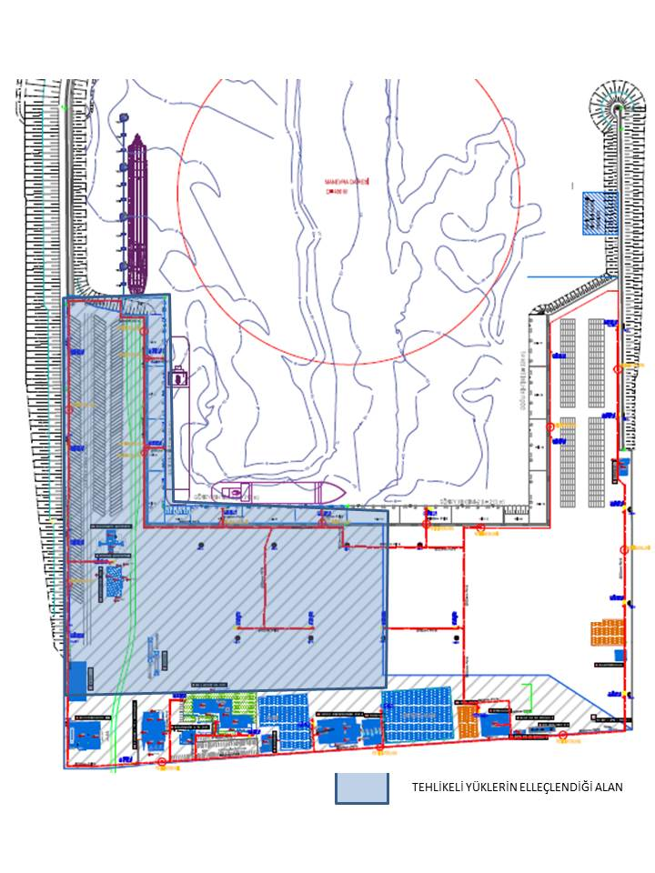

ASSESSMENT OF HAZARDOUS LOADS

4-1

ANNEX-5
FIRE PLAN OF FIELD THAT DANGEROUS GOODS HANDLED

POST INDICATOR VALVE

SAHRA TYPE FIRE DOLLAR

FIRE HYDRANTI-OD.DN150

5-1

ANNEX-6
General Fire Plan of Facility
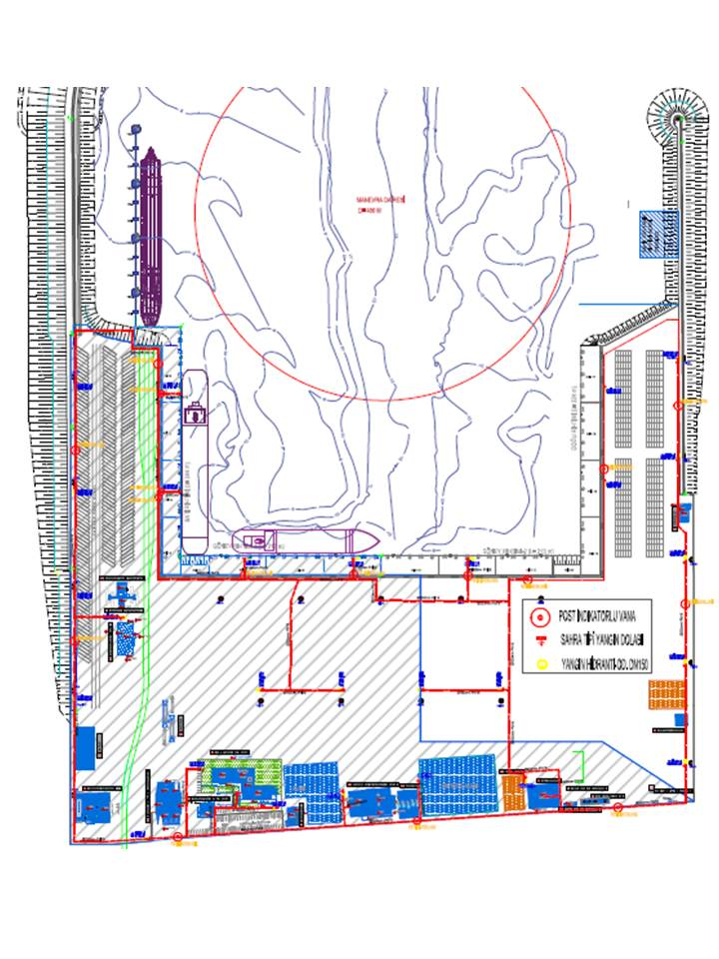

POST INDICATOR VALVE

SAHRA TYPE FIRE DOLLAR

FIRE HYDRANTI-OD.DN150

6-1

ANNEX-7
EMERGENCY ACTION PLAN

KARASU PORT FACILITY
THE EMERGENCY ACTION PLAN IS INSIDE

7-1

ANNEX-8

MERGENCY MEETING POINT

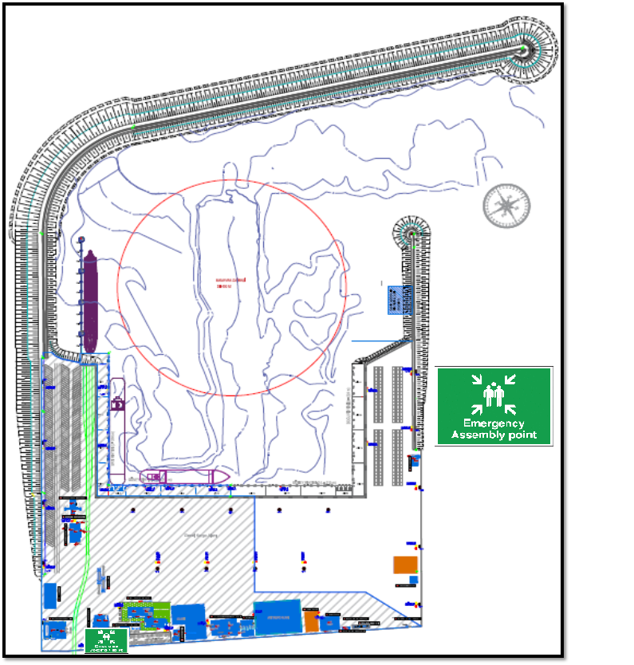

8-1

ANNEX-9
EMERGENCY MANAGEMENT PLAN
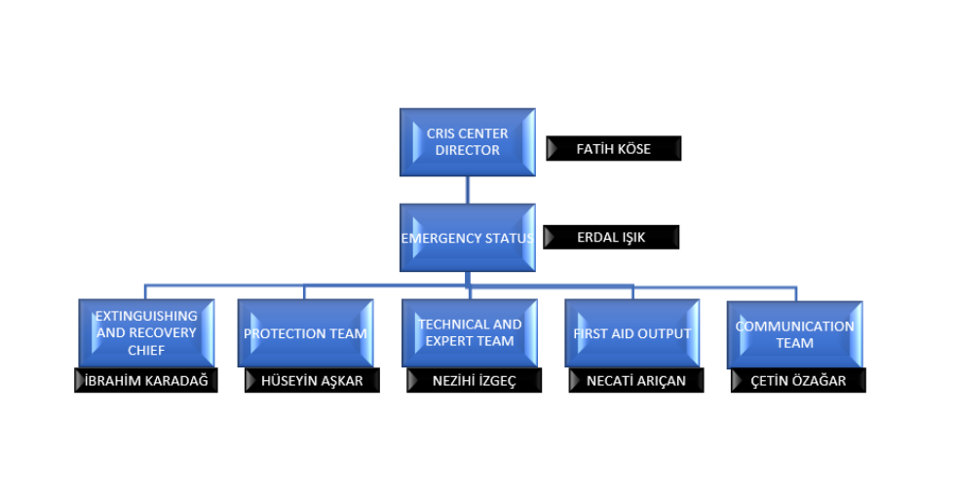 9-1

ANNEX-10
DANGEROUS GOODS MANUAL

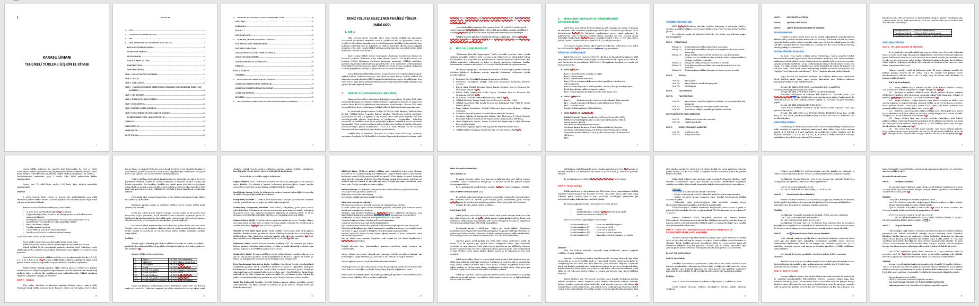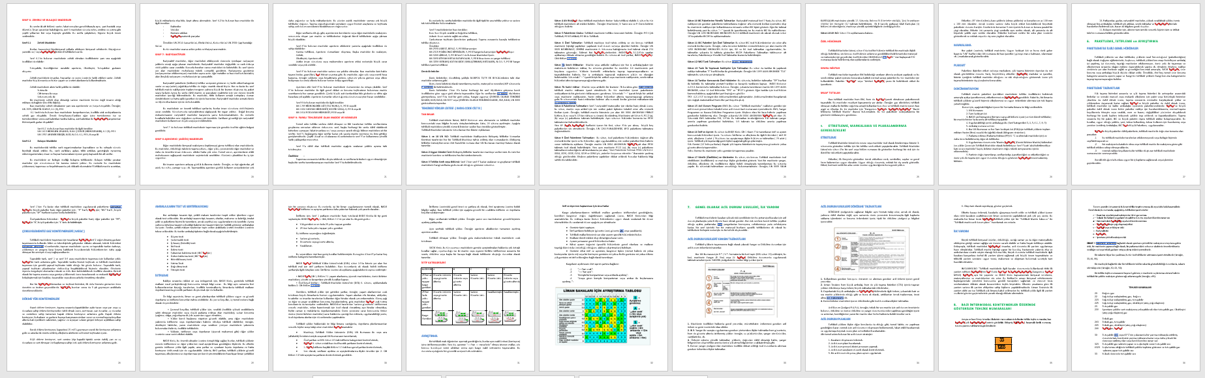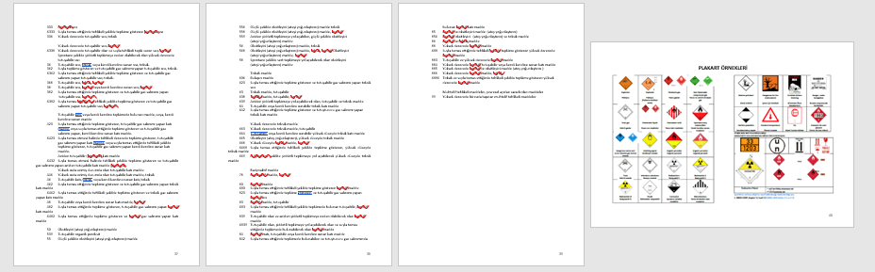

ANNEX-11
SPACE AND EQUIPMENT FOR CTU AND PACKAGES, INPUT / OUTPUT DRAWINGS

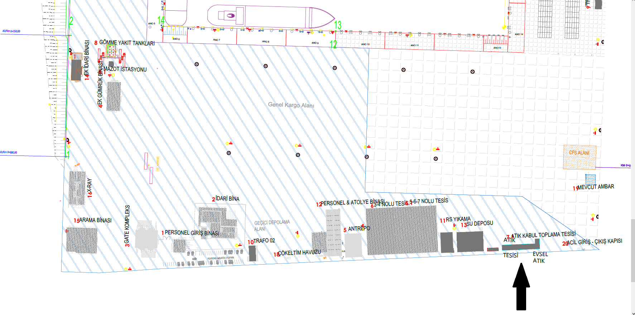

ANNEX-12
INVENTORY OF PORT SERVICE SHIPS

The inventory of Port Service Ships consists of the ships in the table.

BOAT NAME | TYPE OF SHIP | OWNER | TENSILE POWER | CONSTRUCTION YEAR | DISPATCH SYSTEM | MACHINE BRAND AND POWER
IC KARASU | TUGBOAT | IC İÇTAŞ | 30 TON | 2008 | ASD | CAT 2X820 KW
IC KARASU | TUGBOAT | IC İÇTAŞ | 30 TON | 2010 | ASD | CAT 2X820 KW
IC İNCİLLİ | MOORING BOAT | IC İÇTAŞ | N/A | 2015 | KONVANSİYONEL | IVECO 177 BHP
IC PİLOT | PILOT BOAT | IC İÇTAŞ | N/A | 2016 | KONVANSİYONEL | YANMAR 180 BHP

12-1

ANNEX-13 KARASU HARBOUR MASTER ADMINISTRATIVE BOUNDARIES, ANCHORING LOCATIONS AND MARINE COORDINATES OF HARBOR PILOT LANDING/BOARDING POINTS

- Port Administrative Area Boundary
The administrative area of Karasu Port Directorate is the sea and coastal area bounded by Turkish territorial waters and the area between the line drawn in the true north direction from coordinate (a) and the line drawn in the true 320° direction from coordinate (b).
a) 41° 10' 44" N – 030° 22' 03" E
b) 41° 06' 57" N – 031° 17' 48" E

- Anchorage Areas
a) Anchorage Area No. 1:

This anchorage area is designated for vessels not carrying dangerous cargo and for naval ships. It is the sea area enclosed by the following coordinates:
- 41° 06' 00" N – 030° 44' 36" E
- 41° 07' 00" N – 030° 44' 36" E
- 41° 08' 00" N – 030° 42' 48" E
- 41° 07' 00" N – 030° 42' 48" E
b) Anchorage Area No. 2:
This anchorage area is designated for vessels carrying dangerous cargo, nuclear-powered naval vessels, vessels under quarantine, and vessels that will perform gas-freeing operations. It is the sea area enclosed by the following coordinates:
- 41° 10' 24" N – 030° 25' 36" E
- 41° 11' 54" N – 030° 25' 36" E
- 41° 12' 30" N – 030° 23' 12" E
- 41° 11' 12" N – 030° 23' 12" E

13-1

ANNEX-14
EMERGENCY RESPONSE EQUIPMENT AGAINST MARINE POLLUTION IN PORT FACILITY

Regarding the marine pollution, the type and amount of Emergency Response Equipment at the port facility shall be provided through the termination plan agreed with the contract signed with MEKE MARINE - MEKE SEA CLEANING and WASTE COLLECTION SERVICES INDUSTRY.

14-1

ANNEX-15
PERSONAL PROTECTIVE EQUIPMENT(PPE) USE MAP

- BUSINESS HANDBOOK - TWO YEARS
- STEEL NOSE BUSINESS SHOES (SUMMER) - ONE YEAR 1
- STEEL NOSE BUSINESS SHOES (WINTER) - ONE YEAR 1
- BARET - ONE YEAR 1
- PROTECTIVE GLOVES – EXTERIOR
- SINGLE USE FILTER MASK - IN NEED
• REFLECTORS VELOPE - 2 STARS A YEAR

15-1

ANNEX-16
NOTIFICATION FORM FOR DANGEROUS GOODS INCIDENT

1. | Emergency local history and time
2. | Place to Win
3. | Emergency Type (Example: Fire, Fuel Spill, Personnel Injury) and Winning Arrivals (Example: What was it?)
4. | Control Measurement Damage. What was done to control the emergency?
5. | Death / Injured / Lost - Number of company employees in the accident
6. | Death / Injured / Lost - Number of contractors / drivers in the accident
7. | Damage to facilities or equipment owned by the company
8. | The amount of product lost / recovered by the company
9. | Damage to the contractor's terminal or equipment
10. | Other damage the contractor is exposed to
11. | Impact on company operations
12. | Emergency states, affected by
13. | The reaction of the square to occur or expected to occur
14. | Equipment and / or product quality checks made
15. | Center's review
16. | Consequences of corrective actions regarding the cause of the emergency

16-1

ANNEX-17

NOTICE OF CONTROL RESULTS FOR DANGEROUS LOAD TRANSPORT UNITS (CTU)

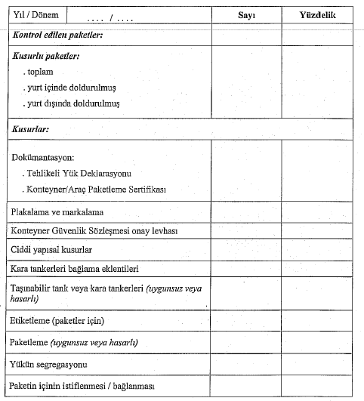

17-1

ANNEX-18
MULTIMODAL DANGEROUS GOODS FORM
1.Shipper/Consignor/Sender | 2.Transport document number | 1.Shipper/Consignor/Sender
 |  | 3.1 page of….page
6.Consignee |  | 7.Carrier(to be completed by the carrier)
SHIPPER’S DECLARATION
I hereby declare that content of this consignment are fully and accurately described below by the Proper Shipping Name and are classified, packaged, marked and labelled/placarded and are in all respects in proper condition for transport according to the applicable international and national governmental regulations.

8.This shipment is within the limitation prescribed for: |  | 9.Additional handling information
PASSENGER AND CARGO AIR PLANE | ONLY CARGO AIR PLANE | PASSENGER AND CARGO AIR PLANE
10.Vessel/flight no.and date | 11.Port/place of loading | 10.Vessel/flight no.and date
12.Port/place of discharge | 13.destination | 12.Port/place of discharge
14.Marks of shipment Number and kind of packages, description, gross mass(kg) net mass(kg)Cube(m³)
15.Container identification no/vehicle registration no | 16.Seal number(numbers) | 15.Container identification no/vehicle registration no | 16.Seal number(numbers) | 15.Container identification no/vehicle registration no
CONTAINER/VEHICLE PACKING CERTIFICATE  I hereby declare that goods described above have been packed/loaded into the container/vehicle identified above in accordance with the applicable provisions.  MUST BE COMPLETED AND SIGNED FOR ALL CONTAINER/VEHICLE LOADS BY PERSON RESPONSIBLE FOR PACKING/LOADING | 21.RECEIVING ORGANIZATION RECEIPT  Received the above number of packages/containers/trailers in apparent good order and condition, unless stated hereon. ORGANIZATION REMARK:
20.Name of company | Haulier’s name  Vehicle reg.no  Signature and date | 22.Name of company
Name /status of declarant | Haulier’s name  Vehicle reg.no  Signature and date | Name /status of declarant
Place and date | Haulier’s name  Vehicle reg.no  Signature and date | Place and date
Signature of declarant | Driver’s signature | Signature of declarant
18-1

ANNEX-19

DANGEROUS LOAD HANDLING GUIDE ADDITIONAL LOAD NOTICE

The cargo notification that is not specified in the current Dangerous Goods Guide of the facility and is planned to be handled at the facility is made to the relevant Port Authority by filling out the form below. According to the code to which the load in question is subject and the attached safety data sheet, the coastal facility has the equipment to be found in the facility, first aid, fire, safety, etc. to be taken. must show that all necessary precautions have been taken and necessary updates have been made in the Dangerous Goods Handling Guide and other procedures.

19-1

11.ABBREVIATIONS

AFAD, Disaster and Emergency Management Presidency

ASTM: American Society for Testing and Materials (ASTM International, 100 Barr Harbor Drive, PO Box C700, West Conshohocken, PA, 19428-2959, USA),

ACEP: Approved Ongoing Inspection Program (located on container plate),

B.B.B. : Not specified otherwise (dangerous goods are placed at the end of the appropriate shipping names),

CGA: Compressed Gas Association (CGA, 14501 George Carter Way, Suite 103, Chantilly, VA 20151, USA),

CCC: IMO Cargo and Container Transport Subcommittee,

CSC: International Convention on Safe Containers as amended,

CTU Code: IMO/ILO/UNECE Code of Practice for Packing Cargo Transport Units (MSC.1/Circ.1497),

CTU: Freight transport unit (similar units used in intermodal transportation such as freight containers, swap bodies, trucks, wagons)

DSC: IMO Dangerous Goods, Solid Cargoes and Containers Subcommittee,

ECOSOC: Economic and Social Council (UN),

EmS: Revised Emergency Response Procedures for Ships Carrying Dangerous Goods,

EN (standard): European standard published by the European Committee for Standardization (CEN, AvenueMarnix 36, B-1050 Brussels, Belgium),

FAO: Food and Agriculture Organization (FAO, Viale delle Terme di Caracalla, 00100 Rome, Italy),

HNS Convention: International Convention on Liability and Indemnity for Damage Related to the Carriage of Dangerous and Harmful Goods (IMO),
IAEA: International Atomic Energy Agency (IAEA) (International Atomic Energy Agency), (IAEA, P.O. Box 100 - A - 1400 Vienna, Austria),

IBC Code: International Code on the Construction and Equipment of Ships Carrying Dangerous Chemical Cargo in Bulk,

ICAO: International Civil Aviation Organization (ICAO, 999 University Street, Montreal, Quebec H3C 5H7, Canada),

IEC: International Electrotechnical Commission (IEC, 3 rue de Varembe, P.O. Box 131, CH-1211 Geneva 20, Switzerland) ,

IGC Code: International Code on the Construction and Equipment of Ships Carrying Liquefied Gas in Bulk,

ILO: International Labor Organization/Office (ILO, 4 route des Morillons, CH-1211 Geneva 22, Switzerland),

IMDG Code: International Code for Dangerous Goods Transported by Sea,

IMGS: International Medical Guide for Ships,

IMO: International Maritime Organization (IMO, 4 Albert Embankment, London SE1 7SR, United Kingdom),

IMSBC Code: International Maritime Solid Bulk Cargo Code International Code for Solid Bulk Cargo Transported by Sea,

INF Code: International Code for the Safe Carriage of Packaged, Radiated Nuclear Fuel, Plutonium and High Level Radioactive Wastes on Ships,

ISO (standard) : An international standard published by the International Organization for Standardization (ISO, 1, ch de la Voie-Creuse, CH-1211 Geneva 20, Switzerland),

ISPS Code: International Ship and Port Facility Security Code,

MARPOL: International Convention for the Prevention of Pollution of the Seas by Ships, 1973, as amended by the relevant 1978 and 1997 protocols,

MAWP: Maximum allowable working pressure,

MEPC: Marine Environment Protection Committee (IMO),

MFAG: Medical First Aid Guide for Use in Accidents involving Hazardous Substances,

MSC: Maritime Safety Committee (IMO),
PEAR Harmful to People, Environment, Property and Reputation

SADT: self-accelerating decomposition temperature,

SAPT: self-accelerating polymerization temperature,
SDS, Material Safety Data Sheet

SOLAS: International Convention for the Safety of Life at Sea, 1974, as amended.
UATF, National Waste Transport Form

UNECE: United Nations Economic Commission for Europe (UNECE, Palaisdes Nations, 8-14 avenue de la Paix, CH-1211 Geneva 10, Switzerland)

UN Number: The four-digit United Nations Number for dangerous and harmful substances, materials and items that are frequently transported,

UNEP: United Nations Environment Program (United Nations Avenue, Gigiri, PO Box 30552, 00100, Nairobi, Kenya),

UNESCO/IOC: UN Educational, Scientific and Cultural Organization/Intergovernmental Oceanographic Commission (UNESCO/IOC, 1 rue Miollis, 75732 Paris Cedex 15, France),

VHF: Marine Band Radio

WHO: World Health Organization (Avenue Appia 20, CH-1211 Geneva 27, Switzerland),

WMO: World Meteorological Organization (WMO, 7bis, avenue de la Paix, Case postale No 2300, CH-1211 Geneva 2, Switzerland) ,
means.

12.DEFINITIONS

Interface means a dock, pier, breakwater, quay, pier, marine terminal or similar structure (floating or not) to which a ship can be moored. This includes any facility or property other than the vessel used directly or indirectly for the loading or unloading of dangerous cargoes.

Port Facility means any person or institution that controls the operation of a port on a daily basis.

Bulk means cargoes intended to be transported in a tank permanently fixed on or inside the Ship, or without a bulkhead for storage in the cargo area that is a structural part of a ship.

Cargo companies means a shipper (shipper), carrier, forwarder, groupage agent, packing center or any person, company or institution involved in any of the following activities: identification, containment, packaging, packaging, securing of dangerous cargoes, Receiving cargo in port, transporting it by sea and always have control over the cargo in relation to its labeling, placarding or documentation.

Certificate of Conformity means a document issued by or on behalf of the Administration in accordance with the relevant laws for the ship's structure and equipment, certifying that the ship's structure and equipment are suitable for the dangerous cargoes to be transported on the ship.

Dangerous goods, within the scope of the following documents, means any of the following cargoes, whether they are packaged, packaged or transported in bulk:

1) Petroleum and petroleum products included in the International Convention for the Prevention of Pollution of the Seas by Ships (MARPOL) 73/78 Annex I, Attachment 1,
2) Packaged goods and objects given in Part 3 of the IMDG Code,
3) Among the cargoes given in the IMSBC Code Attachment 1, the bulk cargoes with the words "B" and "A and B" in the group box in the characteristic table,
4) Liquid substances with the phrase "S" or "S/P" in the "d" column titled "hazards" of the table given in Chapter 17 of the IBC Code,

Certificate of Conformity means a document issued by or on behalf of the Administration to a ship carrying dangerous goods in bulk in solid form or in packaged form under SOLAS regulation II-2/19.4, which proves that the structure and equipment comply with the requirements of the regulation.

Handling, including interim holding operations such as the temporary storage of dangerous cargoes in the port area during their transport from the point of origin to the destination route for the purpose of changing the means and methods of transport and movement within the port, which forms part of the transport supply chain for cargoes, and from a ship, rail car, vehicle, freight This includes loading or unloading operations from a container or other means of transport, intermediate transport between ships or other modes of transport, or transfer within a ship or in a warehouse or terminal area. This term has been expanded to include all operations related to dangerous cargoes in the port area. .

Hot work means any open fire and flame, power tools or hot rivets, grinding, welding, burning, cutting, welding or other repair work involving heat or causing sparks, which may become dangerous due to the presence or proximity of dangerous loads.

Captain means the person in command of a ship. Pilot is not included.

Packing refers to the packaging, loading and loading of dangerous cargoes to recipients, intermediate containers for bulk transport (IBCs), freight containers, tank containers, portable tanks, railroad wagons, bulk containers, vehicles, ship barges or other cargo transport units.

The port area means the land and sea area determined by the legislation.

Note: Some port areas may overlap and legal requirements must be taken into account. When establishing the definition of the port area in legal regulations, care must be taken to ensure that the law applies to all facilities that may be involved.

Port Authority means any person or institution authorized to implement effective control in the port area.

Administration(s) means the national, regional or local administration that has the authority to enforce the legal requirements and is empowered to enforce the legal requirements in relation to a port area.

Person Responsible means a ship's master or someone appointed by a shore-side employer, who is certified or otherwise recognized by the Regulatory Authority as required, has sufficient knowledge and experience for that purpose, and is empowered to make all decisions regarding a specific assignment.

Ship means any watercraft, whether or not suitable for seagoing, used for the carriage of dangerous cargoes, including those used in inland waters.

Ship's stores means materials on board for the maintenance, containment, safety, use or navigation of the ship (excluding fuel and compressed air used for the ship's primary propulsion machinery or fixed auxiliary equipment) or for the safety or comfort of the ship's passengers or crew.

It is stated that the ship's stores contain these items, including those for the comfort of passengers and crew, that a ship may need for normal operation, but not items that a ship may carry for the performance of its specialist functions, e.g. explosives carried by a deep-sea rescue vessel or dangerous goods used by a well propulsion vessel.

Stacking means the positioning of packages, intermediate bulk containers (IBCs), freight containers, tank containers, portable tanks, bulk containers, vehicles, onboard barges, other cargo transport units, and bulk cargoes on the ship's deck, holds, sheds or other areas. is coming.

Transportation means moving in port areas by one or more means of transport.

Unstable substance means a substance that, due to its chemical structure, tends to polymerize or otherwise give dangerous reactions under certain temperature conditions or when in contact with a catalyst. Reducing this tendency can be accomplished through special shipping conditions or by using sufficient quantities of chemical inhibitors or stabilizers in the product.

13.INTRODUCTION

This Guide applies to the entry and presence of dangerous goods in port areas, both on board and on shore. These are intended to be made applicable to all ships visiting a port, regardless of their flag. It should not be applied to ships' stores and equipment, or to troop transports and warships.

2.1 The purpose of this section is to help drafters of national legal requirements ensure that such requirements are made as effective as possible by specifying all possible situations of dangerous goods in cargo areas, but without validating for exceptional cases.

It is important that definitions are carefully studied and used to avoid misunderstanding.

